IB Biology 11 (HL) 2026/2027

Welcome to IB Biology. The curriculum will be divided between grade 11 and 12 and will all be examined in May of grade 12.

In IB Biology 11, we will cover: In IB Biology 12, we will cover:

Early Life on Earth

Cell Biology
- Viruses
- Molecular Biology (most of it)
- Nucleic Acids
- Ecology
- Evolution and biodiversity
- Genetics

Plant biology
- Additional Molecular biology
- Metabolism, cell respiration and photosynthesis
- Human physiology
- Animal physiology
- Additional Ecology

In both grades we will also do practical activities such as labs, computer simulations, and field studies. Students will also be introduced to the Scientific Investigation assignment in grade 11 and we will practice skills that will be used in grade 12 when we complete this individualized paper.

A detailed list of all the IB Biology learning outcomes will be handed out in class.
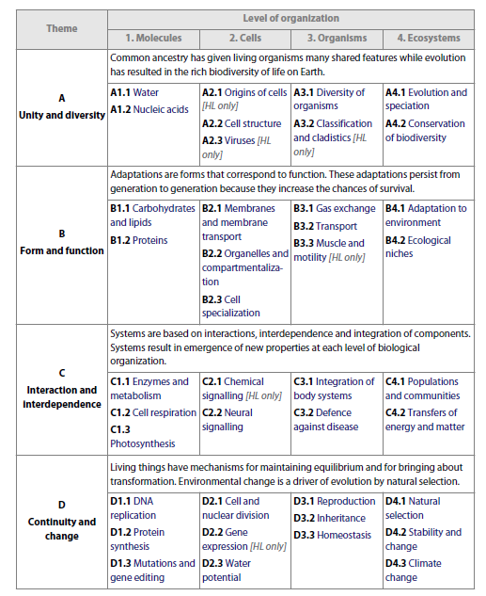

Evaluation

Students will be assessed through a variety of assignments, labs and tests
- Formative strategies – Students will practice their learning with feedback. It is not counted toward final grade, but builds skills and knowledge that will be applied in summative strategies.

- Summative – Final demonstration of learning. These are written assessments that are a mix of multiple choice and short answer questions. There will also be verbal assessments, in which students are asked to individually explain processes.

Each topic will be weighted to reflect the number of learning outcomes that students must meet. As per PMSS’s IB Assessment Policy, students will be assessed according to the IB 7 point scale, which reflects which level students are currently at with respect to the IB Biology learning outcomes. This scale mark will then be converted to a percentage following a rubric created by UBC for report cards. UBC’s scale takes into account the added difficulty and workload required by IB.

Current Estimated IB grade | Report Card %
7 | 98-100
6 | 96-97
5 | 90-95
4 | 86-89
3 | 76-85
2 | 50-75
1 | 0-49

PMSS Work Habits rubric
Criteria | N | S | G
Punctuality | Consistently arrives late | Usually arrives on time | Arrives on time and ready to start
Works Independently | Distracts others; not on task; requires close supervision | Usually focused on task; may need some supervision | Remains on task without reminders; works quietly and efficiently
Initiative | Has difficulty starting to work; doesn’t ask for help; doesn’t get caught up after absence; doesn’t participate | Participates when asked; begins to work when assignment given; works hard most of the time | Volunteers to ask and answer questions; will help others; knows what needs to be done and does it
Homework | Few assignments and homework complete | Homework and assignments usually completed | Homework and assignments complete
Teamwork | Interrupts, distracts, or disrupts others; difficult to work with | Usually cooperative; participates and follows the lead of others | Consistently demonstrates cooperation, respect, and leadership

Resources
- Textbook: Biology 2022 Edition Allott and Mindorff
- Notes, powerpoints and videos used in class can also be found in the IB Biology 11 Class on Teams.

Expectations

  - PMSS’s IB Academic Integrity Policy is expected to followed at all times. Please refer to it on the school’s website, and make sure you understand all of the expectations.
    - You are expected to work on your own to complete all assignments. Lab partners may collect data together, but the presenting of the data, calculations, discussions and conclusions in labs write ups must be completed independently. Working together constitutes academic dishonesty and is a form of plagiarism that is not acceptable.

    - Plagiarism is not tolerated in any form. You may not use material from the internet, or print material, without referencing. Artificial Intelligence (AI) generated work is not accepted and AI edited work is no longer your own. Work done by a tutor and previous course work from a friend is considered plagiarism. Telling your peers what is on a test, or asking for assessment information is academic dishonesty. Please see the PMSS Academic Honesty Policy for more information.

  - All lab work and assignments must be landed in on time, at the beginning of class. If something needs to be printed, it must be done ahead of time, and be ready to hand in at the start of class.

  - Please email me if you will be absent from class, so that I can outline the topics that you will need to catch up on.

  - If you miss class on the day that we have an assessment, you must have your parent email me directly that morning. We can then set a new time for the assessment to be completed.

  - Please feel free to send me questions by e-mail and Teams.

Office Hours

- As IB 11 and 12 classes are longer, we will not usually have Flex block available to work with students (and students may not have flex time either). You should find me at lunch, or send messages so that we can arrange to meet.

Final IB Biology Assessment (May 2027)
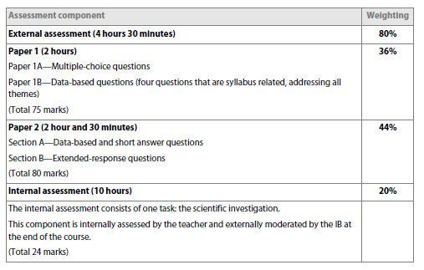
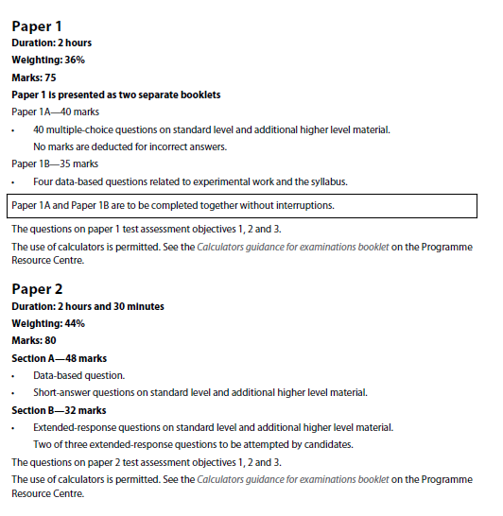

Group 4 Aims

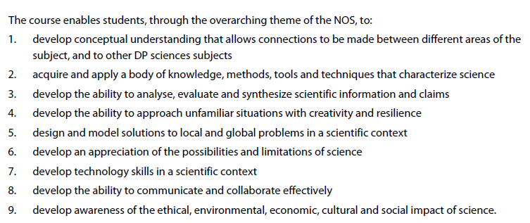

Assessment Objectives
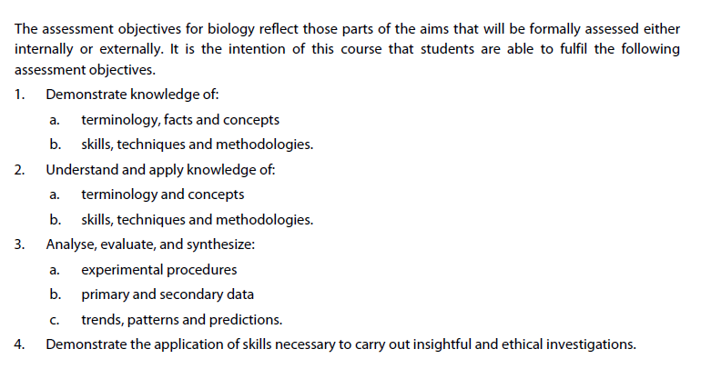

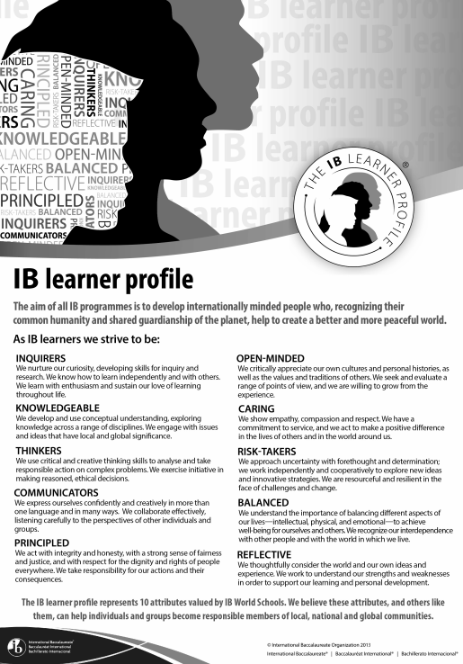

Approaches to Teaching and Learning
The IB Diploma Programme Approaches to Teaching and Learning are deliberate strategies, skills, and attitude that permeate the IB Teaching and Learning environment. The IB believes that a large influence on a student’s education is not only what you learn by how you learn. Teaching students how to learn will improve the quality of teaching and learning across the entire IB spectrum of programmes.

The IB approaches to learning skills are:
- Thinking skills
- Communication skills
- Social skills
- Self-management skills
- Research skills
The IB approaches to teaching skills are:
- based on inquiry
- focused on conceptual understanding
- developed in local and global contexts
- focused on effective teamwork and collaboration
- differentiated to meet the needs of all learners
- informed by formative and summative assessment.

Links to Theory of Knowledge
- In Theory of Knowledge, students will be introduced to 5 Areas of Knowledge (Language, Arts, Human Sciences, Natural Sciences and Mathematics) and 4 elements of each area of knowledge (Scope, Methods/Tools, Perspectives and Ethics). In IB Biology, we will connect to the TOK course content as we learn about the history and production of biological knowledge. We will also ask knowledge questions that relate to the content, particularly in the areas of perspectives and ethics.

International Mindedness

- Science itself is an international endeavour—the exchange of information and ideas across national boundaries has been essential to the progress of science. Indeed, the idea that science is a Western invention is a myth—many of the foundations of modern-day science were laid many centuries before by Arabic, Indian and Chinese civilizations, among others. The scientific method in its widest sense, with its emphasis on peer review, open-mindedness and freedom of thought, transcends politics, religion, gender and nationality. Increasingly there is a recognition that many scientific problems are international in nature and this has led to a global approach to research in many areas.
- Throughout the two year of IB Biology, students will be introduced to examples of international efforts working together to increase scientific knowledge and examine how scientific breakthroughs affect people in different regions of the world.

