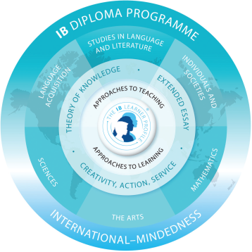Welcome to IB Geography Higher Level (HL)
Mr. D. Bolognese
Office: Graduation Transitions Office 3055
Phone Number: 604.939.6656
Email: dbolognese@sd43.bc.ca
Instagramr: reallifegeographun

The International Baccalaureate program is designed for students who are mature and highly motivated. Students are expected to work on their own or in small groups. Students are expected to listen and share ideas. Students are expected to think about concepts from a local and global perspective.
Geography is a dynamic subject that is grounded in the real world and focuses on the interactions between individuals, societies and physical processes in both time and space (IB Geography Guide, 2019). Geography is a course best learned through active participation and discussion. My hope is that Geography will open your mind to the human, physical and environmental aspects of the world we live in and create a greater understanding of international mindedness and ethical behavior.
Theory of Knowledge and CAS experiences connect to each subject group. The subject of Geography will allow you to connect Geography to TOK and Geography topics to your CAS experiences.
For Example:
TOK – how has ready access to vast amounts of information and the way the internet has contributed to our shrinking world, changed our understanding of knowledge?
CAS – volunteering at a senior’s home, feeding the homeless, tutoring young people, writing your government official, promoting sustainable development…

Electronic Device(s)
Laptops, smart phones and/or tablets are useful in this class. You will be asked to bring them with you. Policies will be discussed.

- Arrive on time and prepare to work.
- Participate fully and positively.
  - Maintain an open mind and a positive attitude. Be ready to listen, learn and share your ideas.
  - I expect you to participate by working individually and with others.
  - Some topics might be hard to listen to BUT keep an open mind and engage…
- Always put in your best effort
- All assignments, large or small, are important and will “count”.
- Putting in your best effort means doing YOUR OWN WORK. All assignments, essays and projects that are to be handed in for marks are expected to be of a quality suitable for the grade level. Assignments must be well researched and neatly presented. (see PMSS handbook)
- Always show courtesy and respect.
- RESPECT yourself, your teachers and your classmates
- Listen actively to whomever is speaking – another student, me, the announcements, etc. We all have the right to be heard and therefore it is imperative that we do not call out over others.
- Don’t be absent! But if you are…
- It is your responsibility to come to me to find out what you have missed
- You need to be here to learn…so some assignments cannot be made up for marks.
- Tests – be here to write them. It is important that you do not miss any tests.
- Keep up to date! Check your marks! Hand in your work on time!
- Cheating
- If you are caught cheating, you will be referred to the office.
- You are responsible for your own learning…and I am here to help!
- I am available for tutorial – drop by or make an appointment.
- Predicted Grades
- I predict your grade
- Technology:
I strongly recommend students bring a laptop, or tablet to class. The use of technology in the classroom can be great for research, or looking up concepts etc. But technology can also be a distraction and draw students away from learning. I will go over the expectation in class, and I ask that you follow my rules. Failure to do this will result in me asking you not to bring the device to class.
- Electronic Devices – mobile phones must be placed on SILENT and AWAY. Failure to do this will result in a warning, removal from class, email home or a referral to the office. 😊
- AI – the use of AI is encouraged but remember it is a tool and should not be used to generate student work.

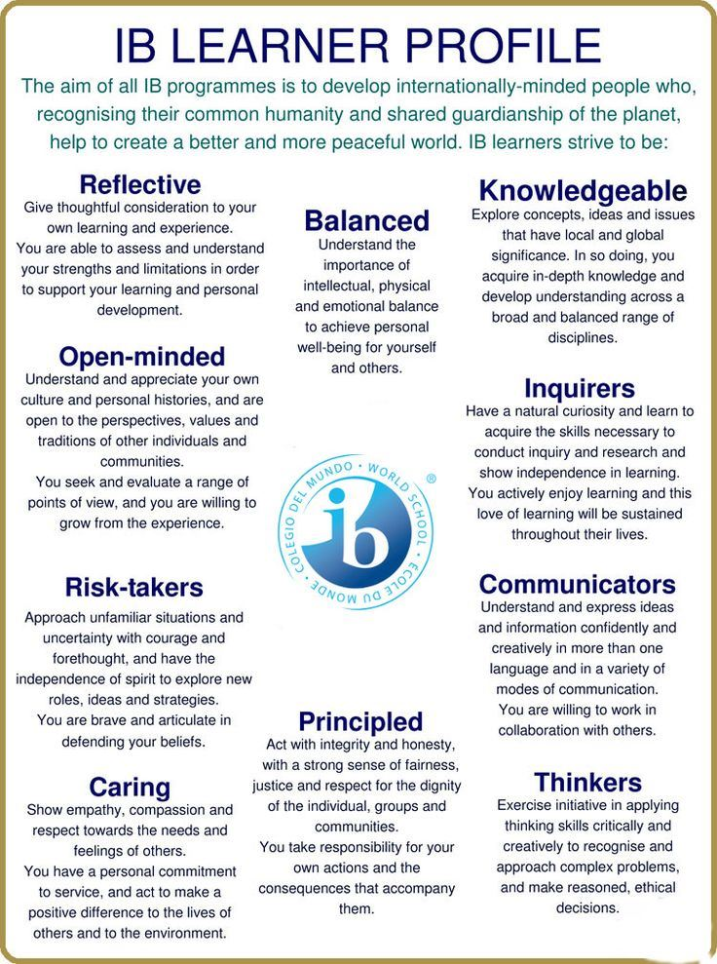
Textbooks – Planet Geography for IB Diploma Program – Stephen Codrington
- Our Dynamic Planet (Paper 1)
- Our Changing Planet (Paper 2)
- Our Connected Planet (Paper 3)
- Online and in the classroom Oxford IB Geography 2nd edition

Geographic Perspectives – Global Change Grade 11 – Paper Two – Exam (50 marks)

Paper 2 – HL weight 25%, a total of 1hours and 15 minutes. Section A - Three structured questions based on each HL core unit 30 marks. Section B - Infographics or visual stimulus with structured questions 10 marks. Section C – one extended answer question from a choice of two 10 marks

- Population Distribution – Changing Population
  - Population and economic development patterns
  - Changing population and places
  - Challenges and opportunities
- Global Climate – vulnerability and resilience
  - Causes of global climate change
  - Consequences of global climate change
  - Responding to global climate change
- Global Resource consumption and security
  - Global trends in consumption
  - Impacts of changing trends in resource consumption
  - Resource stewardship
- One option will be taught in the Grade 11 year
- Internal assessment will commence in the Grade 11 year

Geographic Themes Grade 12 (teacher will choose 3 options) - Paper One (60 marks)

Paper 1 – HL weight 35%, 45 minutes per option question a total of 2 hours and 15 minutes. Each option has a structured question and one extended answer question from a choice of two. 20 marks (10 + 10) marks per option
- Freshwater- Drainage Basins Option A
  - Drainage Basing Hydrology and Geomorphology
  - Flooding and Flood Mitigation
  - Water Scarcity and Water Quality
  - Water management and futures
- Oceans and their coastal margins Option B
- Extreme environments Option C
- Geophysical Hazards Option D
- Leisure, Tourism and Sport Option E
  - Changing leisure patterns
  - Tourism and sport at the local and national scale
  - Tourism and sport at the international scale
  - Managing tourism and sport for the future
- Food and Health Option F
  - Measuring Food and Health
  - Food systems and spread of diseases
  - Stakeholders in food and health
  - Future health and food security and sustainability
- Urban Environments Option G
Geographic Perspectives – Global Interactions -Paper Three (28 marks) Exam 1 hour (20%)

Paper 3 – HL weight 20%, a total of 1hour. Choice of three extended questions with two parts based on each HL Core Extension. Part A – 12 marks Part B – 16 marks

- Power, places and networks
  - Global interactions and global power
  - Global networks and flows
  - Human and physical influences on global interactions
- Human Development and Diversity
  - Development opportunities
  - Changing identities and cultures
  - Local responses to global interactions
- Global Risk and resilience
  - Geopolitical and economic risks
  - Environmental risks
  - Local and global resilience

IB Internal Assessment – 25 marks (20%)
The Internal assessment is compulsory for the success and completion in this course. It allows students to investigate a topic of choice in detail. Internal assessment allows students to apply what they have learned in the course to a study. For Geography HL the internal assessment is worth 20% and requires students to spend approximately 20 hours inside and outside of the classroom. Students will receive guidance from their teacher.
Some important notes:
Teachers are only allowed to give advice to students on their first draft and the comments must be brief. The second draft is final, and teachers are NOT allowed to give any further feedback.

*Geographic skills will be taught throughout the course:
For Example:

- Read, interpret, analyze and produce maps
- Interpret topographic maps where appropriate
- Read, interpret, analyze and construct graphs
- Undertake statistical calculations to show patterns and change
- Manipulate and interpret data using qualitative techniques
- Undertake geographical investigation
- Produce written material
Examination tips will be provided throughout the course

Mark Breakdown
Ministry of Education Marks | IB Mark Breakdown
Grade 11  100% Assignments and tests from the prescribed learning outcomes  Grade 12  100% Assignments and tests from the prescribed learning outcomes and (non-moderated) Internal Assessment | All assignments and tests will be based on the IB scale model (1-7). This model will be used to evaluate how well you are able to understand the Prescribed Learning Outcomes  See Group 3 Grade Descriptors
Work Habits
Work habits are based on the rubric below and each student’s ability to complete the canned notes that are assigned after each unit.

Criteria | N (needs improvement) | S (satisfactory) | G (good)
Punctuality | Consistently arrives late to class; misses part the lesson. | Usually arrives on time and is ready to start. | Arrives on time to class and ready to start learning.
Works Independently | Distracts others; not on task; requires close supervision. | Usually focused on task; may need supervision. | Remains on task without reminders; works efficiently.
Initiative | Has difficulty starting work; doesn’t ask for help; doesn’t participate in class. | Participates when asked; begins to work when assignment given; works hard most of the time. | Volunteers to ask and answer questions; will help others; knows what needs to be done and does it.
Homework | A few assignments and homework complete; answers not checked or corrected. | Homework and assignments usually completed; answers are usually checked and corrected. | Homework and assignments complete; answers have been checked and corrections are made.
Organization | Little attempt to organize notebook or bring textbook, pencils, paper, homework, etc. | Needs some organization of notebook; supplies and materials usually brought to class. | Notebook is organized and complete; supplies and materials present; keeps track of all homework, assignments, and important dates.
Teamwork | Interrupts, distracts, or disrupts the learning environment; | Usually cooperative; participates and follows the lead of others. | Demonstrates cooperation, respect, and leadership.

Group 3 Grade Descriptors
Grade 7 Excellent performance
Demonstrates: conceptual awareness, insight, and knowledge and understanding which are evident in the
skills of critical thinking; a high level of ability to provide answers which are fully developed, structured in a logical and coherent manner and illustrated with appropriate examples; a precise use of terminology which is specific to the subject; familiarity with the literature of the subject; the ability to analyze and evaluate evidence and to synthesize knowledge and concepts; awareness of alternative points of view and subjective and ideological biases, and the ability to come to reasonable, albeit tentative, conclusions; consistent evidence of critical reflective thinking; a high level of proficiency in analyzing and evaluating data or problem solving.
Grade 6 Very good performance
Demonstrates: detailed knowledge and understanding; answers which are coherent, logically structured and well developed; consistent use of appropriate terminology; an ability to analyze, evaluate and synthesize knowledge and concepts; knowledge of relevant research, theories and issues, and awareness of different perspectives and contexts from which these have been developed; consistent evidence of critical thinking; an ability to analyze and evaluate data or to solve problems competently.
Grade 5 Good performance
Demonstrates: a sound knowledge and understanding of the subject using subject-specific terminology.
answers which are logically structured and coherent but not fully developed; an ability to provide competent answers with some attempt to integrate knowledge and concepts; a tendency to be more descriptive than evaluative although some ability is demonstrated to present and develop contrasting points of view; some evidence of critical thinking; an ability to analyze and evaluate data or to solve problems.
Grade 4 Satisfactory performance
Demonstrates: a secure knowledge and understanding of the subject going beyond the mere citing of isolated, fragmentary, irrelevant or ‘common sense’ points; some ability to structure answers but with insufficient clarity and possibly some repetition; an ability to express knowledge and understanding in terminology specific to the subject; some understanding of the way facts or ideas may be related and embodied in principles and concepts; some ability to develop ideas and substantiate assertions; use of
knowledge and understanding which is more descriptive than analytical; some ability to compensate for gaps in knowledge and understanding through rudimentary application or evaluation of that knowledge; an ability to interpret data or to solve problems and some ability to engage in analysis and evaluation.
Grade 3 Mediocre performance
Demonstrates: some knowledge and understanding of the subject; a basic sense of structure that is not
sustained throughout the answers; a basic use of terminology appropriate to the subject; some ability to
establish links between facts or ideas; some ability to comprehend data or to solve problems.
Grade 2 Poor performance
Demonstrates: a limited knowledge and understanding of the subject; some sense of structure in the
answers: a limited use of terminology appropriate to the subject; a limited ability to establish links between facts or ideas; a basic ability to comprehend data or to solve problems.
Grade 1 Very poor performance
Demonstrates: very limited knowledge and understanding of the subject; almost no organizational structure in the answers; inappropriate or inadequate use of terminology; a limited ability to comprehend data or to solve problems.

External assessment markbands—HL

Paper 1 SL and HL part b) (optional themes) and paper 2 SL and HL part b

Maximum mark 10 (2 marks per band)

The level descriptors per markband below describe characteristics of a typical response appropriate to a specific mark range. Verbs in bold in the criteria refer to the command terms. For the full definition, please refer to the “Glossary of command terms” section.

Marks |  | Level descriptor
 |  | AO1: Knowledge and |  | AO3: Synthesis and |  | AO4: Selection, use and
 |  | understanding of specified |  | evaluation |  | application of a variety of
 |  | content |  |  |  | appropriate skills and
 |  | AO2: Application and analysis |  |  |  | techniques
 |  | of knowledge and
 |  | understanding
0 |  | The work does not reach a standard described by the descriptors below.
1–2 |  | The response is too brief, lists unconnected information, is not focused on the question
 |  | and lacks structure.
 |  | • | The response is very brief or | • | No evidence of evaluation | • | Information presented
 |  |  | descriptive, listing a series |  | or conclusion is expected |  | is not grouped logically
 |  |  | of unconnected comments or |  | at this level. |  | (in paragraphs or
 |  |  | largely irrelevant information. |  |  |  | sections).
 |  |  | The knowledge and |  |  | • | Maps, graphs or
 |  |  | understanding presented is |  |  | • | Maps, graphs or
 |  |  | understanding presented is |  |  |  | diagrams are not
 |  |  | very general with large gaps |  |  |  | diagrams are not
 |  |  | very general with large gaps |  |  |  | included, are irrelevant
 |  |  | or errors in interpretation. |  |  |  | included, are irrelevant
 |  |  | or errors in interpretation. |  |  |  | or difficult to decipher
 |  |  | Examples or case studies |  |  |  | or difficult to decipher
 |  |  | Examples or case studies |  |  |  | (only if appropriate to
 |  |  | are not included or only |  |  |  | (only if appropriate to
 |  |  | are not included or only |  |  |  | the question).
 |  |  | listed. |  |  |  | the question).
 |  | • | There is no evidence of
 |  |  | analysis.
 |  | • | Terminology is missing, not
 |  |  | defined, irrelevant or used
 |  |  | incorrectly.

3–4 |  | The response is too general, lacks detail, is not focused on the question and is largely
 |  | unstructured.
Marks |  | Level descriptor
 |  | AO1: Knowledge and |  | AO3: Synthesis and |  | AO4: Selection, use and
 |  | understanding of specified |  | evaluation |  | application of a variety of
 |  | content |  |  |  | appropriate skills and
 |  | AO2: Application and analysis |  |  |  | techniques
 |  | of knowledge and
 |  | understanding
 |  | • | The response is very | • | If appropriate to the | • | Most of the information
 |  |  | general. The knowledge and |  | question, the conclusion |  | is not grouped logically
 |  |  | understanding presented |  | is irrelevant. |  | (in paragraphs or
 |  |  | outlines examples, | • | There is no evidence of |  | sections).
 |  |  | statistics, and facts that are | • | There is no evidence of | • | Maps, graphs or
 |  |  | statistics, and facts that are |  | critical evaluation of | •
 |  |  | both relevant and irrelevant. |  | critical evaluation of | •
 |  |  | both relevant and irrelevant. |  | evidence (examples, |  | diagrams included lack
 |  |  | Links to the question are |  | evidence (examples,
 |  |  | Links to the question are |  | statistics and case |  | detail, are incorrectly
 |  |  | listed. |  | statistics and case
 |  |  | listed. |  | studies). |  | or only partially
 |  | • | The argument or analysis |  | studies).
 |  | • | The argument or analysis |  |  |  | interpreted without
 |  |  | presented is not relevant to |  |  |  | explicit connections to
 |  |  | the question. |  |  |  | the question (only if
 |  | • | Basic terminology is defined |  |  |  | appropriate to the
 |  | • | Basic terminology is defined |  |  |  | question).
 |  |  | and used but with errors in
 |  |  | understanding or used
 |  |  | inconsistently.
5–6 |  | The response partially addresses the question, but with a narrow argument, an
 |  | unsubstantiated conclusion, and limited evaluation.
 |  | • | The response describes | • | If appropriate to the | • | Logically related
 |  |  | relevant supporting evidence |  | question, the conclusions |  | information is grouped
 |  |  | (information, examples, case |  | are general, not aligned |  | together (in sections or
 |  |  | studies et cetera), outlining |  | with the evidence |  | paragraphs) but not
 |  |  | appropriate link(s) to the |  | presented and/or based |  | consistently.
 |  |  | question. |  | on an incorrect | • | Maps, graphs or
 |  | • | The argument or analysis |  | interpretation of the | •
 |  | • | The argument or analysis |  | interpretation of the |  | diagrams included do
 |  | • | The argument or analysis |  | evidence.
 |  |  | partially addresses the |  | evidence. |  | not follow conventions,
 |  |  | partially addresses the | • | Other perspectives on
 |  |  | question or elaborates one | • | Other perspectives on |  | and include relevant
 |  |  | point repeatedly. |  | evidence (examples, |  | and irrelevant
 |  | • | Relevant terminology is |  | statistics and case |  | interpretations in the
 |  | • | Relevant terminology is |  | studies) and/or strengths |  | text (only if appropriate
 |  |  | defined and used with only |  | studies) and/or strengths
 |  |  | defined and used with only |  | and weaknesses of |  | to the question).
 |  |  | minor errors in |  | and weaknesses of
 |  |  | minor errors in |  | evidence are listed.
 |  |  | understanding or is used |  | evidence are listed.
 |  |  | inconsistently.

7–8 |  | The response addresses the whole question, the analysis is evaluated and the
 |  | conclusion is relevant but lacks balance.
 |  | AO1: Knowledge and |  | AO3: Synthesis and |  | AO4: Selection, use and
 |  | understanding of specified |  | evaluation |  | application of a variety of
 |  | content |  |  |  | appropriate skills and
 |  | AO2: Application and analysis |  |  |  | techniques
 |  | of knowledge and
 |  | understanding
 |  | • | The response describes | • | If appropriate to the | • | Logically related
 |  |  | relevant supporting evidence |  | question, the conclusion |  | information is grouped
 |  |  | correctly (information, |  | is relevant to the |  | together (in sections)
 |  |  | examples and case studies) |  | question, aligned with the |  | consistently.
 |  |  | that covers all the main |  | evidence but unbalanced. | • | Maps, graphs or
 |  |  | points of the question, | • | Other perspectives on |  | diagrams included
 |  |  | describing appropriate links | • | Other perspectives on |  | diagrams included
 |  |  | to the question. |  | evidence (examples, |  | contribute to/support
 |  |  | to the question. |  | statistics and case |  | the argument or
 |  | • | The argument or analysis is |  | statistics and case |  | the argument or
 |  | • | The argument or analysis is |  | studies) and/or strengths |  | analysis (only if
 |  |  | clear and relevant to the |  | and weaknesses of |  | appropriate to the
 |  |  | question but one-sided or |  | evidence are described. |  | question).
 |  |  | unbalanced.
 |  | • | Complex terminology is
 |  |  | defined and used correctly
 |  |  | but not consistently.
9–10 | The response is in-depth and question-specific (topic and command term); analysis and
 |  | conclusion are justified through well-developed evaluation of evidence and
 |  | perspectives.
 |  | • | The response explains | • | If appropriate to the | • | Response is logically
 |  |  | correct and relevant |  | question, the conclusion |  | structured with
 |  |  | examples, statistics and |  | is relevant to the |  | discussion (and if
 |  |  | details that are integrated in |  | question, balanced and |  | appropriate to the
 |  |  | the response, explaining the |  | aligned with the evidence. |  | question, a conclusion)
 |  |  | appropriate link to the | • | Evaluation includes a |  | focusing on the
 |  |  | question. | • | Evaluation includes a |  | argument or points
 |  |  | question. |  | systematic and detailed |  | argument or points
 |  | • | The argument or analysis is |  | systematic and detailed |  | made, making it easy
 |  | • | The argument or analysis is |  | presentation of ideas, |  | made, making it easy
 |  | • | The argument or analysis is |  | presentation of ideas, |  | to follow.
 |  |  | balanced, presenting |  | cause and effect |  | to follow.
 |  |  | balanced, presenting |  | cause and effect | •
 |  |  | evidence that is discussed, |  | relations, other | • | Maps, graphs or
 |  |  | explaining complexity, |  | perspectives; strengths |  | diagrams are
 |  |  | exceptions and comparisons. |  | and weaknesses of |  | annotated following
 |  | • | Complex and relevant |  | evidence are discussed; |  | conventions and their
 |  | • | Complex and relevant |  | (if appropriate) includes |  | relevance is explained
 |  |  | terminology is used correctly |  | (if appropriate) includes |  | relevance is explained
 |  |  | terminology is used correctly |  | justification of the |  | and support the
 |  |  | throughout the response. |  | justification of the |  | and support the
 |  |  | throughout the response. |  | argument and conclusion. |  | argument or analysis
 |  |  |  |  |  |  | (only if appropriate to
 |  |  |  |  |  |  | the question).

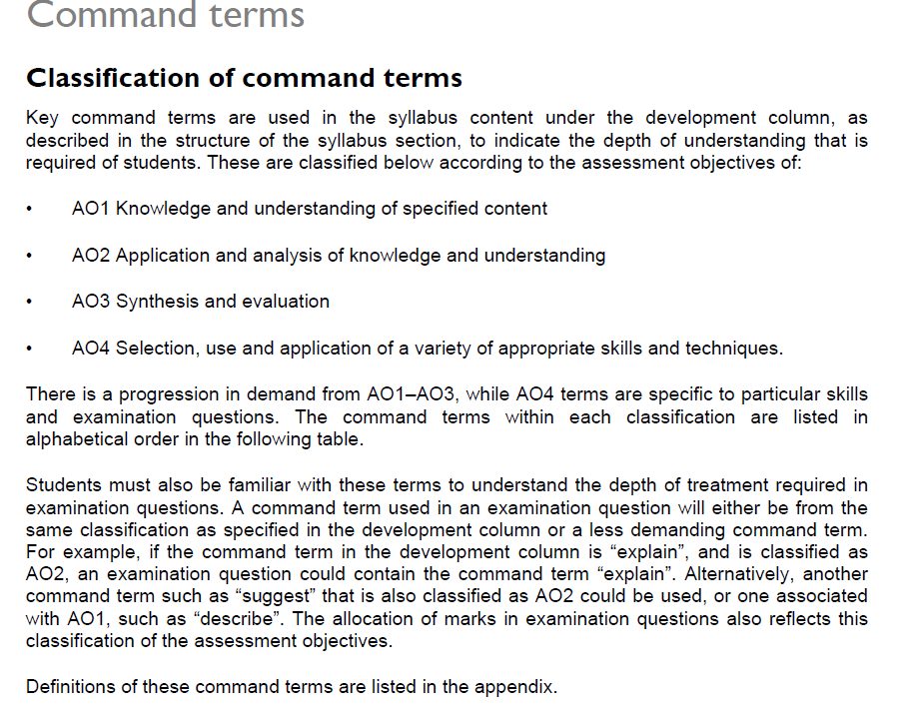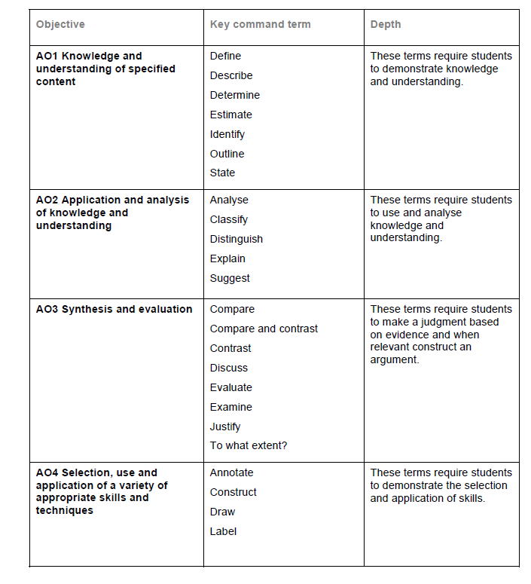
Command terms with definitions

Students should be familiar with the following key terms and phrases used in examination questions, which are to be understood as described below. Although these terms will be used frequently in examination questions, other terms may be used to direct students to present an argument in a specific way.

Analyse |  | AO2 | Break down in order to bring out the essential elements or
 |  |  | structure.
Annotate |  | AO4 | Add brief notes to a diagram or graph.
Classify |  | AO1 | Arrange or order by class or category.
Compare |  | AO3 | Give an account of the similarities between two (or more) items
 |  |  | or situations, referring to both (all) of them throughout.
Compare and contrast |  | AO3 | Give an account of similarities and differences between two (or
 |  |  | more) items or situations, referring to both (all) of them
 |  |  | throughout.
Construct |  | AO4 | Display information in a diagrammatic or logical form.
Contrast |  | AO3 | Give an account of the differences between two (or more) items
 |  |  | or situations, referring to both (all) of them throughout.
Define |  | AO1 | Give the precise meaning of a word, phrase, concept or
 |  |  | physical quantity.
Describe |  | AO1 | Give a detailed account.
Determine |  | AO1 | Obtain the only possible answer.
Discuss |  | AO3 | Offer a considered and balanced review that includes a range
 |  |  | of arguments, factors or hypotheses. Opinions or conclusions
 |  |  | should be presented clearly and supported by appropriate
 |  |  | evidence.
Distinguish |  | AO2 | Make clear the differences between two or more concepts or
 |  |  | items.
Draw | AO4 |  | Represent by means of a labelled, accurate diagram or graph,
 |  |  | using a pencil. A ruler (straight edge) should be used for straight
 |  |  | lines. Diagrams should be drawn to scale. Graphs should have
 |  |  | points correctly plotted (if appropriate) and joined in a straight
 |  |  | line or smooth curve.
Estimate | AO1 |  | Obtain an approximate value.
Evaluate | AO3 |  | Make an appraisal by weighing up the strengths and limitations.
Examine | AO3 |  | Consider an argument or concept in a way that uncovers the
 |  |  | assumptions and interrelationships of the issue.
Explain | AO2 |  | Give a detailed account including reasons or causes.
Identify | AO1 |  | Provide an answer from a number of possibilities.
Justify | AO3 |  | Give valid reasons or evidence to support an answer or
 |  |  | conclusion.
Label | AO4 |  | Add labels to a diagram.
Outline | AO1 |  | Give a brief account or summary.
State | AO1 |  | Give a specific name, value or other brief answer without
 |  |  | explanation or calculation.
Suggest | AO2 |  | Propose a solution, hypothesis or other possible answer.
To what extent | AO3 |  | Consider the merits or otherwise of an argument or concept.
 |  |  | Opinions and conclusions should be presented clearly and
 |  |  | supported with empirical evidence and sound argument.

