IB LANGUAGE A: LITERATURE (YEAR ONE)
2026-2027
Port Moody Secondary Mr. P. White, Ms. J. Nelsen
300 Albert Street Office: English Office (North and South)
Port Moody, B.C., V3H 2M5 Email: pwhite@sd43.bc.ca, jnelsen@sd43.bc.ca
604.939.6656
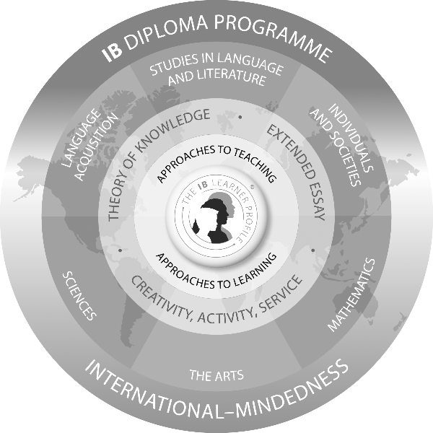
The International Baccalaureate program is designed for students who are mature and highly motivated. Students are expected to work on their own or small groups. Students are expected to listen and share ideas. Students are expected to think about concepts from a local and global perspective.
This course is built on the assumption that literature is concerned with our conceptions, interpretations and experiences of the world. The study of literature can therefore be seen as an exploration of the way it represents the complex pursuits, anxieties, joys and fears to which human beings are exposed in the daily business of living.
It enables an exploration of one of the more enduring fields of human creativity, and provides opportunities for encouraging independent, original, critical and clear thinking. It also promotes respect for the imagination and a perceptive approach to the understanding and interpretation of literary works.
Through the study of a wide range of literature, the language A: literature course encourages students to appreciate the artistry of literature and to develop an ability to reflect critically on their reading. Works are studied in their literary and cultural contexts, through close study of individual texts and passages, and by considering a range of critical approaches.

What Am I Going to Learn?
The aims of Language A: Literature are to:
- introduce students to a range of texts from different periods, styles and genres
- develop in students the ability to engage in close, detailed analysis of individual texts and make relevant connections
- develop the students’ powers of expression, both in oral and written communication
- encourage students to recognize the importance of the contexts in which texts are written and received
- encourage, through the study of texts, an appreciation of the different perspectives of people from other cultures, and how these perspectives construct meaning
- encourage students to appreciate the formal, stylistic and aesthetic qualities of texts
- promote in students an enjoyment of, and lifelong interest in, language and literature
- develop in students an understanding of the techniques involved in literary criticism
- develop the students’ ability to form independent literary judgments and to support those ideas

Our Classroom Expectations
- Be present. This means more than just showing up to class on time and for the entire block.
  - No mobile devices or music players at any time. These devices are proven to be a detrimental distraction to focus and attention in a learning environment. I will have a place to store any device brought to class.
  - Leaving the classroom during the period will be restricted to appropriate times. Although eating and drinking during class is acceptable, they will not be allowed to interfere with or disrupt the learning environment.
- Incremental improvement. You each bring a wealth of knowledge and understanding to class. It is expected that you improve on this knowledge and understanding each and every day. Writing skills take time to develop. Over the course of the semester, you will see gradual improvement in writing quality and scores.
  - Read all texts and supplemental material when assigned. It is recommended that students go beyond the classroom material to seek out connections to subject areas of personal interest. Avail yourself of academic databases and read articles on course texts.
  - Speak up during class. Oral communication is an essential skill to all areas of one’s adult life. This is a skill that can and should be improved throughout high school, so it is expected that you participate assertively in discussions.
  - Finish all work on time. Deadlines are set to help students and teachers get through all course material in time.
- Be inspired. Literature is a playground for the most profound ideas and concepts that humans are capable of imagining.
  - Find a connection. Even if we find it difficult to enjoy a particular piece of writing, we must recognize that reading literature is an experience in connecting with the imagination of another human from another time and place. We teach these texts for a reason—it is your job to figure a reason why you are studying them.
  - Make it relevant. Creativity has to be worked at and creating connections between subject material and our personal experience is necessary to making the most of our educational journey. Some of the greatest thinkers were mathematicians, astronomers, microbiologists, teachers, military generals and satirists; literature is a medium that we can all relate to.
PMSS Code of Conduct
Students will:
- respect oneself, others, and the school’s facility and grounds
- engage in responsible behaviour in all learning and school activities (attend classes regularly, in your seat by the second bell, prepared for class, participate thoughtfully, respect other classmates’ comments, complete all assignments, hand assignments in when due, ask for help when you need assistance, demonstrate good manners and good common sense)
- help to ensure the school environment is a safe and caring place for all to learn
- inform an adult of an unsafe individual, unsafe behaviour, and/or an unsafe or violent situation
- model respectful and responsible behaviour at school, in the community, and while acting as school ambassadors
- cite your research sources (text, sound, music, graphics, pictures, video clips, etc.) refer to the “Ethics of Information Use” (see Agenda App under ‘Intellectual Dishonesty’)
- dress appropriately for the school learning environment in a manner that is respectful toward oneself and others
- exercise responsible digital citizenship (particularly social media use) “District 43 Digital Responsibility for Students Administrative Policy 140.2”
- not discriminate against a person or class of persons on the basis of the Indigenous identity, race, colour, ancestry, place of origin, marital status, family status, age, religion, sex or sexual orientation, gender identity or expression, physical or mental disability, age of that person or class of persons or for any other reason set out in the Human rights Code of British Columbia (Section 7 and 8), nor shall a student publish or display anything that would indicate an intention to discriminate against another, or expose them to contempt or ridicule, on the basis of any such grounds

*students may be subject to discipline under the school and/or District Code of Conduct for any conduct which has the effect of negatively impacting the school environment, whether that conduct occurs on or off School District property, at a school sponsored function or activity, or otherwise
Link to the PMSS Code of Conduct: https://www.sd43.bc.ca/school/portmoody/About/COC/Pages/default.aspx#/=

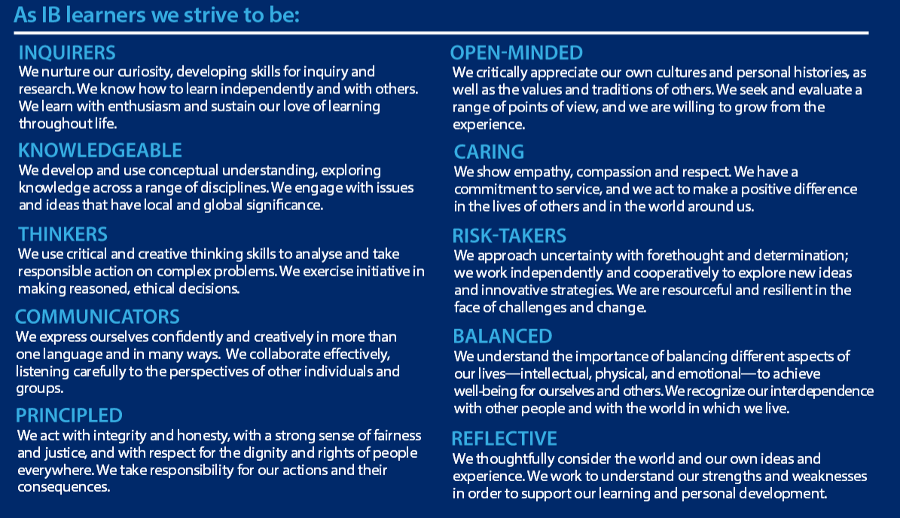

Course Breakdown for Language A: Literature Year One

Work | Author | Genre | Period | Origin | Areas of Exploration | Class Dates
Oedipus Rex | Sophocles | Drama | 429 BCE | Europe (Greece) | Time and Space | September – October
5 Little Indians | Michelle Good | Prose – Novel | 21st c | North America (Canada) | Time and Space | November - December
Macbeth | William Shakespeare | Drama | 17th c | Europe (England) | Intertextuality | January - February
1984 | George Orwell | Prose – Novel | 20th c | Europe (England) | Readers, Writers, and Texts | February - March
The Prince | Niccolo Machiavelli | Non-Fiction | 13th c | Europe (Italy) | Intertextuality | April - May
The Road | Cormac McCarthy | Prose – Novel | 21st c | North America (USA) | Readers, Writers, and Texts | June
HL Essay Draft |  |  |  |  |  | Due: May ___, 2027
*These texts are subject to change due to resource availability and other considerations.

Learning Strategies
Class activities will consist of individual and structured group work, interactive discussion, reflective writing tasks, impromptu writes, online activities, inquiry-based problem solving, research and investigation, and presentations.
There may, on occasion, be field trip opportunities or special guest speakers.

Assessment
There are three assessment objectives for the Language A: Literature course.

1. | Knowledge and understanding
 | - Demonstrate knowledge and understanding of individual literary works as representatives of their genre and period, and the relationships between them
 | - Demonstrate an understanding of the ways in which cultural values are expressed in literature
 | - Demonstrate awareness of the significance of the context in which a work is written and received
 | - Substantiate and justify ideas with relevant examples
2. | Analysis, synthesis and evaluation
 | - Demonstrate an ability to analyze language, structure, technique and style, and evaluate their effects on the reader
 | - Demonstrate an ability to engage in independent literary criticism on both familiar and unfamiliar literary texts
 | - Show an ability to examine and discuss in depth the effects of literary techniques and the connections between style and meaning
3. | Selection and use of appropriate presentation and language skills
 | - Demonstrate an ability to express ideas clearly and fluently in both written and oral communication, with an effective choice of register and style
 | - Demonstrate a command of terminology and concepts appropriate to the study of literature
 | - Demonstrate an ability to express well-organized oral and written arguments
 | - Demonstrate an ability to write a sustained and detailed literary commentary

All written and oral work for this course will be assessed according to the appropriate rubric.

Classroom Assessment - Grade 11 Year
A variety of assessment instruments will be used throughout the year including, but not limited to, quizzes, presentations, short written assignments, essays, and more!
Assessment by teacher, student self-assessment, and student peer-assessment will all be considered in the generation of a letter grade for reporting purposes.

Language A: Studies in Literature Grade Descriptors
Grade 7
Demonstrates excellent understanding and appreciation of the interplay between form and content in regard to the question or task; responses that may be convincing, detailed, independent in analysis, synthesis and evaluation; highly developed levels of expression, both orally and in writing; very good degree of accuracy and clarity; very good awareness of context and appreciation of the effect on the audience/reader; very effective structure with relevant textual detail to support a critical engagement with the thoughts and feelings expressed in the work(s).

Grade 6
Demonstrates very good understanding and appreciation of the interplay between form and content in regard to the question or task; responses that are, mainly, convincing, as well as detailed and independent to some degree, in analysis, synthesis and evaluation; well-developed levels of expression, both orally and in writing; good degree of accuracy and clarity; good awareness of context and appreciation of the effect on the audience/reader; effective structure with relevant textual detail to support a critical engagement with the thoughts and feelings expressed in the work(s).

Grade 5
Demonstrates good understanding and appreciation of the interplay between form and content in regard to the question or task; responses that offer generally considered and valid analysis, synthesis and / or evaluation; good levels of expression, both orally and in writing; adequate degree of accuracy and clarity; awareness of context and appreciation of the effect on the audience/reader; clear structure with relevant textual detail to support an engagement with the thoughts and feelings expressed in the work(s).

Grade 4
Demonstrates adequate knowledge and understanding of the question or task; responses that are generally valid in analysis and / or synthesis; satisfactory powers of expression, both orally and in writing; only some lapses in accuracy and clarity; some awareness of context and appreciation of the effect on the audience/reader; a basic structure within which the thoughts and feelings of the work(s) are explored.

Grade 3
Demonstrates some knowledge and some understanding of the question or task; responses that are only sometimes valid and / or appropriately detailed; some appropriate powers of expression, both orally and in writing; lapses in accuracy and clarity; limited awareness of context and appreciation of the effect on the audience/reader; some evidence of a structure within which the thoughts and feelings of the work(s) are explored.

Grade 2
Demonstrates superficial knowledge and understanding of the question or task; responses that are of generally limited validity; limited powers of expression, both orally and in writing; significant lapses in accuracy and clarity; little awareness of context and appreciation of the effect on the audience/reader; rudimentary structure within which the thoughts and feelings of the work(s) are explored.

Grade 1
Demonstrates very rudimentary knowledge and understanding of the question or task; responses that are of very limited validity; very limited powers of expression, both orally and in writing; widespread lapses in accuracy and clarity; no awareness of context and appreciation of the effect on the audience/reader; very rudimentary structure within which the thoughts and feelings of the work(s) are explored.

Resources
We will make extensive use of real-world materials such as newspapers, magazines, scholarly journals, internet and the World Wide Web, movies, documentaries, YouTube, TED talks and other relevant media.

IB Approaches to Teaching and Learning
The IB Diploma Programme Approaches to Teaching and Learning are deliberate strategies, skills, and attitude that permeate the IB Teaching and Learning environment. The IB believes that a large influence on a student’s education is not only what you learn by how you learn. Teaching students how to learn will improve the quality of teaching and learning across the entire IB spectrum of programmes.

The IB approaches to learning skills are:
- Thinking skills
- Communication skills
- Social skills
- Self-management skills
- Research skills

The IB approaches to teaching are:
- based on inquiry
- focused on conceptual understanding
- developed in local and global contexts
- focused on effective teamwork and collaboration
- differentiated to meet the needs of all learners
IB Approaches to Learning |  | BC - Core Competencies
Communication | Communication Skills  - Through interaction  - Through language | Communication | Connect and engage with others  Acquire (research), interpret and present  Collaborate  Explain, recount and reflect
Research | Information Literacy Skills  Media Literacy Skills | Communication
Social | Collaboration Skills | Communication
Social | Collaboration Skills | Social Responsibility | Contributing to community/environment  Problem solving  Valuing diversity  Building relationships
Self-Management | Organization Skills  Affective Skills  - Manage your own state of mind  Reflection Skills | Social Responsibility
Self-Management |  | Personal Awareness and Responsibility | Self-determination  Self –regulation  Well-being
Self-Management |  | Positive Personal and Cultural Identity | Relationships and cultural contexts  Personal strengths, abilities, values and choices
Thinking | Critical Thinking Skills  Creative Thinking Skills  Transfer  - Skills and knowledge across different disciplines and subject groups | Creative Thinking | Novelty and value  Generating ideas  Developing ideas
Thinking |  | Critical Thinking | Analyze and critique  Question and investigate  Develop and design
- informed by formative and summative assessment.

The following table illustrates how IB Approaches to Learning align with the BC Ministry of Education’s Core Competencies

