Social Studies 9 Pre-IB
Canada and the World: 1950-1919
Teacher: Ms. C. Arrotta
September 2026 to January 2027
Rm. 311
Email: carrotta@sd43.bc.ca

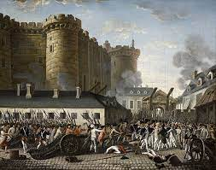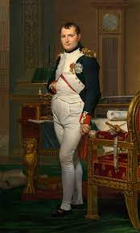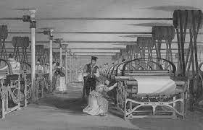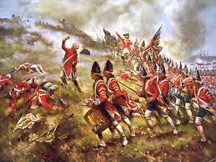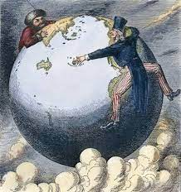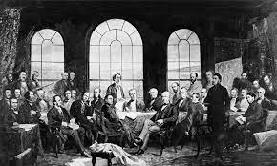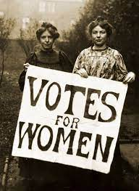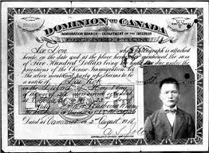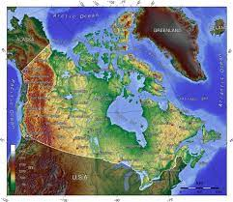

COURSE OBJECTIVES:
The overarching goal of Social Studies 9 is to develop thoughtful, responsible, and active citizens, who can gather the necessary information to consider multiple perspectives. Students will be required to make reasoned ethical judgements about actions in the past and present, and to determine appropriate ways to remember and respond.
Social Studies 9 can be broadly as a history of Western Europe and Canada, from 1750 to 1919. Students will be provided with the opportunity to examine political, social, economic, and technological revolutions, both in Canada and abroad. They will also learn about the continuing effect of imperialism and colonialism on Indigenous peoples in Canada and around the world. They will be exposed to the global demographic shifts, including patterns of migration and population growth. They will examine nationalism and the development of modern nation-states, including Canada’s path to nationhood. We will look at local, regional, and global conflicts. Central themes include discriminatory policies, attitudes, and historical wrongs. Students will also analyze the topic of geography while examine the physiographic features and natural resources of Canada.

BIG IDEAS:
- Emerging ideas and ideologies profoundly influence societies and events.
- The physical environment influences the nature of political, social, and economic change.
- Disparities in power alter the balance of relationships between individuals and between societies.
- Collective identity is constructed and can change overtime.

CORE COMPETENCIES
- Thinking: Students should approach subjects with a mindset of inquiry – asking powerful questions about themselves, the topics, the evidence, and the classroom process.
- Communication: It should be clear to students what they are expected to learn, and students should be able to express clearly what they have learned.
- Personal and Social: Develop good work habits, time management and practice responsibility both for yourself and to the other students with whom you work
STUDENTS ARE EXPECTED TO DO THE FOLLOWING:
- Assess the significance of people, places, events, or developments, and compare varying perspectives on their significance at particular times and places, and from group to group (significance).
- Assess the justification for competing accounts after investigating points of contention, reliability of sources, and adequacy of evidence, including data (evidence).
- Compare and contrast continuities and changes for different groups at particular times and places (continuity and change)
- Assess how underlying conditions and the actions of individuals or groups influence events, decisions, or developments, and analyze multiple consequences (cause and consequence).
- Explain and infer different perspectives on past or present people, places, issues, or events by considering prevailing norms, values, worldviews, and beliefs (perspective).
- Make reasoned ethical judgments about actions in the past and present, and assess appropriate ways to remember and respond (ethical judgment).

Approaches to Learning and Teaching
The IB Diploma Programme Approaches to Teaching and Learning are deliberate strategies, skills, and attitude that permeate the IB Teaching and Learning environment. The IB believes that a large influence on a student’s education is not only what you learn by how you learn. Teaching students how to learn will improve the quality of teaching and learning across the entire IB spectrum of programmes.

The IB approaches to learning skills are:
- Thinking skills
- Communication skills
- Social skills
- Self-management skills
- Research skills

STUDENTS IN PRE-IB WILL ALSO BE ASSESSED UPON THREE OBJECTIVES IN IB FOUNDATIONS SOCIAL STUDIES 10

Assessment objective 1: Knowledge and understanding
- Demonstrate detailed, relevant, and accurate historical knowledge.
- Demonstrate understanding of historical concepts and context.
- Demonstrate understanding through comparison/contrast, connecting, analyzing, and evaluating significance.

Assessment objective 2: Application and analysis
- Formulate clear and coherent arguments.
- Use relevant historical knowledge to effectively support analysis.
- Analyze and interpret a variety of sources.
- Answer questions by applying new skills and/or knowledge

Assessment objective 4: Use and application of appropriate skills
- Produce work that shows evidence of organization and planning
- Use correct grammar and spelling in written output and discussion
- Demonstrate evidence of independent thought and expression (no plagiarism)

IB Learner Profile:
The IB learner profile is at the heart of all IB courses and activities. Adherence to its principles is an important component to the IB program and students are encouraged to follow these principles.
As IB learners we strive to be:
- INQUIRERS - We nurture our curiosity, developing skills for inquiry and research. We know how to learn independently and with others. We learn with enthusiasm and sustain our love of learning throughout life.
- KNOWLEDGEABLE - We develop and use conceptual understanding, exploring knowledge across a range of disciplines. We engage with issues and ideas that have local and global significance.
- THINKERS - We use critical and creative thinking skills to analyse and take responsible action on complex problems. We exercise initiative in making reasoned, ethical decisions.
- COMMUNICATION - We express ourselves confidently and creatively in more than one language and in many ways. We collaborate effectively, listening carefully to the perspectives of other individuals and groups.
- PRINCIPLED - We act with integrity and honesty, with a strong sense of fairness and justice, and with respect for the dignity and rights of people everywhere. We take responsibility for our actions and their consequences.
- OPEN-MINDED - We critically appreciate our own cultures and personal histories, as well as the values and traditions of others. We seek and evaluate a range of points of view, and we are willing to grow from the experience.
- CARING - We show empathy, compassion, and respect. We have a commitment to service, and we act to make a positive difference in the lives of others and in the world around us.
- RISK-TAKERS - We approach uncertainty with forethought and determination; we work independently and cooperatively to explore new ideas and innovative strategies. We are resourceful and resilient in the face of challenges and change.
- BALANCED - We understand the importance of balancing different aspects of our lives — intellectual, physical, and emotional — to achieve well-being for ourselves and others. We recognize our interdependence with other people and with the world in which we live.
- REFLECTIVE - We thoughtfully consider the world and our own ideas and experience. We work to understand our strengths and weaknesses in order to support our learning and personal development.

UNITS OF STUDY:
In this course we will cover the following of units of study, time permitting and following the interest of students learning.
- Unit 1: Geography: Why should we care? The Five Themes, Physical & Natural Regions of Canada, Climates of Canada, Climate Change & Impacts
- ***Overview of the Big 6
- Unit 2: Early Canadian History: Indigenous peoples of Canada, Exploration and early settlement, Life in New France, 7 Years War, and the fall of New France.
- Unit 3: Global Revolutions: What is a Revolution? American Revolution, French Revolution and Rise of Napoleon, Industrial Revolution
- Unit 4: Conflict and Change in British North America: British immigration/migration and the changing demographics of BNA, The War of 1812 and the changing relationship between BNA and the United States, The Rebellions of 1837, and the concerns of Upper and Lower Canada.
- Unit 5: The Emergence & New Problems Facing the Nation of Canada: Confederation, The opening of the West and the fur trade, The CPR and the National Dream, Northwest Rebellion and the Riel resistance at Red River, BC history-Gold Rush, Indigenous Perspectives, Confederation. Last Best West-Immigration Policies, Labour issues and women’s rights, The Laurier Era.
EVALUATION AND ASSESSMENT:
Projects (Individual and Group)
Assessments (Quiz & Tests)
Assignments (Debates, Paragraph Responses, Primary Source Analysis, Reflections, Worksheets, Creative Work, Exit Slips, Readings & Questions, Essay Group Questions)

For Grade 9s, all forms of assessment (tests, projects, and assignments of all kinds) will be evaluated with the proficiency model of reporting provided by the BC Ministry of Education. Interim and Final Grades will follow this model:
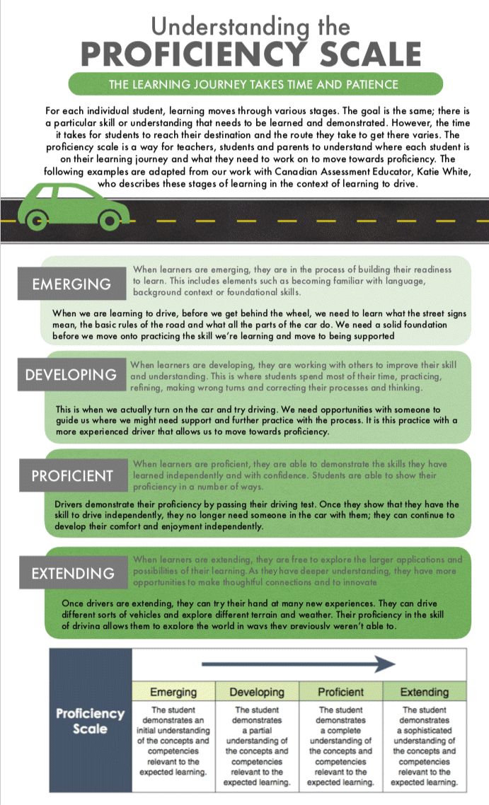
- Extending: The student demonstrates sophisticated understanding of the concepts and competencies in relation to learning standards with increased depth and complexity.
- Proficient: The student demonstrates the expected learning in relation to the learning standard. Student can demonstrate their learning consistently or most of the time.
- Developing: The student is demonstrating learning in relations to the learning standards with growing consistency. The student is showing initial understanding but is still in the process of developing their competency in relation to the learning standards. *** All students will be developing in some curricular competencies at a specific point in time, prior to becoming proficient.**
- Emerging: The student is just beginning to demonstrate learning in relation to the learning standards but is not yet doing so consistently. Emerging is not failing.
- Insufficient Evidence (IE)- Students who are not yet demonstrating any learning in relation to the learning standards with insufficient evidence (not enough assessments completed).

IB Skills Development for DP Program:
Throughout the course of this semester, we will be working upon building analytical & writing skills in preparation for the IB Diploma Program in Grade 11 and 12. In the DP Program, you will have the opportunity to study one to two of the following courses under Group 3 Individual & Societies: Geography HL, History HL or Economics SL. We will be focusing on the following skills:
- Source Analysis: Assessing the origin, purpose, value and limitations of sources
- Critical Thinking: Analyzing issues from multiple perspectives and lenses (cultural, social, political, technological, economic and environmental) and evaluating evidence before forming conclusions. Considering causes, consequences, processes, continuity, changes, interconnections and relationships, and significance of events/issues in history or modern times and at local, regional and global scales.
- Research Skills: Locate, selecting and using/evaluating credible primary and secondary sources effectively. Synthesizing information from multiple sources into coherent conclusions.
- Evidence-Based Argumentation: Constructing clear arguments supported by relevant evidence & examples (aka PEEL/SEEL)
- Data Interpretation: Read & interpret graphs, charts, maps, tables and statistical data

Late/Incomplete Assignments & Absence for Examinations:
If you require an extension for any reason, please ask your teacher prior to the assignment’s due date. You will always be provided class time to complete assignments. You have until the assigned due date to submit your work. Usually, you are provided 2-5 days to complete your assignments. You are, ultimately, responsible for ensuring that all homework/assignments are submitted on a consistent basis.
If you are absent for a quiz or test, it is your responsibility to complete the missing assessment during FLEX time or afterschool. Please email your teacher to arrange a date and time promptly that works best. If it is not completed by the end of the semester, it must be completed during Supplementary Learning Opportunities.
However, if you require additional support or extensions, do not hesitate to ask for assistance or attend FLEX! FLEX is extremely useful to get extra help and support! Accommodations and alternate ways of completing assignments can be done whenever necessary. It is your responsibility to catch up everything you missed if absent. You are expected to arrive to class on time and be respectful of the teacher and others within the classroom environment.

Re-Submitting Assignments/Projects/Examinations
Students may be permitted at times to resubmit or improve a portion of an assignment/project. This will only be done if the teacher requests this on the following basis: if there was a confusion on the requirements of an assignment/project, if a section of an assignment was missed or where there could be a substantial improvement in the work produced. Students cannot resubmit work without the teacher’s approval or be done to improve their total overall score to achieve a perfect mark. Re-submitting assignments will only occur by asking and receiving approval from the teacher. It is to help develop and refine important curricular competencies/skills that will be important in their academic development.
Students will not be permitted to re-take any form of an examination (quiz or test).

Cellphone Policy:
As per the new Ministry BC guidelines, it is expected that each school district implements their own restrictions surrounding phone usage. Within the classroom, it is expected once you enter the classroom, phones are put into the phone hotel and are not to be removed until the end of the class time.
If students do not comply, the first offence (by refusal or by putting a dummy phone in the cellphone hotel), I will confiscate the cellphone & contact parents/guardians including Vice Principals.
If there’s a second time of non-compliance with the cell phone policy, students will be referred directly to their Vice Principal with cell phone(s). A Vice Principal will confiscates the cell phone, and student picks up from the Vice Principal at the end of the day; Vice Principal follows up with parent/guardian.
If there’s a third time of non-compliance with the cell phone policy, students go onto a phone plan with Vice Principal where they must drop off in the AM and pick up after school from the Vice Principal directly until they prove they can manage it appropriately in accordance with the legislation.
If phones are required for any educational purpose, students will be notified. For example, students may be asked to use their phones or laptops for educational purposes such as Kahoots, researching a topic or completing an assignment through Microsoft Word.
Bring Your Own Device:
Port Moody Secondary (SD43) allows students to bring their own laptops or tablets to support learning in class. The school provides secure wireless access, but device use is a privilege for educational purposes and must follow SD43's Digital Responsibility and Appropriate Use policies.
It is the expectation that you will use your devices only when directed or for school-related work. If laptop or iPad usage becomes a problem in class, parents/guardians will be contacted via phone or via email to discuss a plan moving forwards.
Any inappropriate usage of laptop devices in class could result in the item(s) being confiscated and not allowed to be used any longer. It could also result in loss of device privileges and disciplinary consequences under the Code of Conduct.
If laptop or iPad usage becomes a problem in class, parents/guardians will be contacted via phone or via email to discuss a plan moving forwards. Any inappropriate usage of laptop devices in class could result in the item(s) being confiscated and not allowed to be used any longer.

What Can I Expect From This Class?
You can expect to learn a lot if you keep an open-mind and heart. There will be a variety of teacher-led & student-led activities. You can also expect readings from time to time or questions and responses to complete for the next day for review. You can expect a lot of variety in assignments with many individual and group projects, individuals/group discussions/debates & exit-slips, primary source analysis, reflections, simulations, mind maps, paragraphs, analysis & scenario-based assignments/discussions, and kahoots. You will require access to TEAMS. Powerpoints will be always uploaded onto TEAMS.
Tests will be formatted only with a mix of multiple choice, true and/false and written responses. This will include a variety of short answers, paragraph format and document/photo analysis. There will also be maps and sequence of events. All information on examinations will come from lessons, in-class notes, activities and supplemental readings. These tasks will ask you to delve deep into your reflective/critical thinking while challenging your creativity.
Class-work time will be given to complete all tasks. However, it is a privilege to not be abused and that will be taken away if class-time is not used effectively. My intention is to give you as little homework as possible. However, my expectation is that you will use your class time well to complete all your work. You can expect a teacher who values open-communication, hard work and is willing to help you along every step of the way
You can expect a teacher who values open-communication, hard work and is willing to help you along every step of the way. Communication is key! I am always willing to provide you extensions for your homework/assignments and willing to give extra time for quizzes and tests if needed.

How Can I Achieve My Academic Goals?
My philosophy is that grades are earned, not given. If you are willing to put in the hard work, pay attention during class, get involved in discussions, communicate well with me throughout the semester, manage your time well and learn from the feedback that you receive, you should have no problem achieving your academic goals. My job is to help you to succeed on your path, but you have to pave that path yourself.

Absences:
Absences must be excused by a parent/guardian. Extended absences (without a valid excuse) may result in a lower grade than you are capable of, so please attend class. Please contact your teacher if absent to be informed of missing coursework/assignments. Constant communication is always important!
Seating Arrangements
I always start each semester based on the trust system that you are responsible enough to sit where you choose to. However, if the seating becomes distraction to your peers, myself, or you, the whole class will be assigned seating arrangements.

Academic Dishonesty:
It is expected that all student work be original and appropriately sourced (the student must identify when work is not their original idea and appropriately cite the original source). Any student work that is not cited appropriately may be determined to be plagiarized. Plagiarism also includes AI, Snapchat AI or taking your friends old work from similar courses.
Plagiarism is commonly referred to as “the passing off of another person’s work as one’s own, whether deliberate or accidental. Accidental plagiarism is usually the result of poor citation or referencing or poor preparation or a misunderstanding of plagiarism. Deliberate plagiarism is an attempt to claim another person’s work as one’s own”
(http://en.wikipedia.org/wiki/plagiarism).

Consequences of Academic Dishonesty:
Students will receive a zero on the assignment and will have the chance to complete the assignment again during FLEX or afterschool in person. Depending on the severity and times a student has plagiarized a referral to the office, IB Coordinator and/or a phone call home will be completed.
If you have any questions or concerns, please feel free to contact the teacher via the emails provided (carrotta@sd43.bc.ca). We look forward to working with you this semester. If you require extra help or have any questions, please come to FLEX, or email us. I am more than happy to help!

Respect and Safety
You may have heard that Ms. A is pretty “chill” & “easy going”. One thing Ms. A is not “chill” about is disrespect and safety. Our learning environment depends on mutual respect. Please demonstrate your respect for each other and this class. Two critical rules: When Ms. A is teaching a lesson or providing instructions, it is important you are respectful and pay attention. Keep all distractions away (phones, excessive side chats) especially during lessons or instructions for assignments. Always be mindful of your classmates and their needs in class.
Music is acceptable as for some people it does help us focus! Inappropriate conduct in the class that compromises the safety of others will be addressed and brought to the attention of administration and your parents/guardians.

