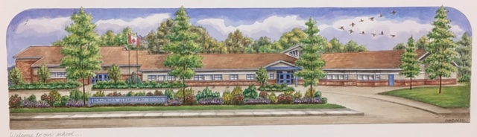
Blakeburn Elementary
Code of Conduct Guidelines: 2026-2027

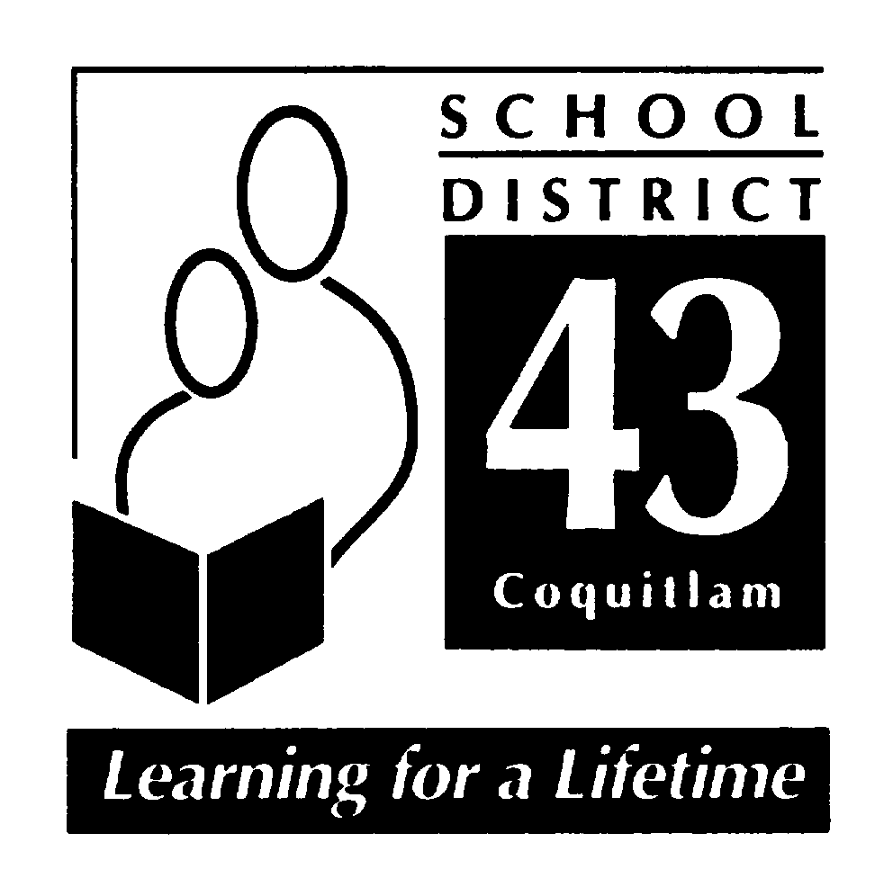

June 2026

- PROCESS

2001: The Blakeburn Code of Conduct was developed and adopted.
2002-2025: Yearly Review of Code of Conduct including the Staff, PAC and students
June 2026
- PAC – draft for June PAC meeting and asked for feedback and input
- Staff – draft reviewed June staff meeting and asked for feedback and input
- Student – students reviewed “student voice” and were asked for feedback and input

- COMMUNICATION

The code of conduct is integrated into our school goals. The school’s foundation is grounded in the social responsibility core competencies and everything we do stems from those philosophies and restorative practices. Therefore, communication occurs through:
- School-wide activities like: Bounce Gatherings, and celebrations.
- Explicit teaching around social responsibility.
- A school-wide opening week program that focuses on incorporating SEL practices and lessons as a means of communicating school wide expectations and our school motto (Take care of yourself, Take care of others, and Take care of this place).
- Communication tools: email, weekly newsletters, planners, SeeSaw, PAC meetings and communicating student learning.
- Personal phone calls, emails, online meetings, parent/teacher conferences, student-led conferences, and school celebrations.

- IMPLEMENTATION

Social Responsibility and SEL is explicitly taught by staff through:
- Student Leadership
- Buddy Classes
- School Gatherings: Bounce, Assemblies, and Celebrations.
- Opening Week program – Take Care of Self, Others, This Place
- Blakeburn Cares Initiatives: Terry Fox Run, Jump Rope for Heart, Reading Week.
- A Restorative Approach to discipline with a focus on strengthening the child.
- Teachers use a variety of self-regulation strategies – including: circles, Zones of Regulation, and Mindup
- Modeling a Growth Mindset by all adults (parents, teachers, staff).

As a school and district, we recognize the importance of modeling respectful and responsible processes for managing conflict. Whenever possible, we try to use a restorative approach to resolving conflict and teaching pro-social behaviors.

The fundamental premise of restorative practice is that people are happier, more cooperative, productive, and more likely to make positive changes to their lives, when those in authority do things “with them”, rather than “to them” or “for them”. (International Institute for Restorative Practices http://www.iirp.edu/what-is-restorative-practices.php). As a result, a focus of behavior intervention should be to help an offender recognize and repair any harm done. Furthermore, the purpose is to teach the offender moving forward, and then reinforce positive behaviors, to return the offender to the school community stronger, and more resilient than before the offense.

Every effort will be made to support all students. However, if there are ongoing conduct issues after having implemented restorative interventions, more traditional discipline approaches may be used, separate or in conjunction with restorative interventions. All disciplinary decisions will be made with respect to the individual and context, and responses to conduct issues will take into consideration the student’s age, maturity, and past conduct.

- MONTORING AND REVIEW

- We monitor students’ social responsibility through report cards.
- We send out the code of conduct to all parents (PAC) and staff in the school community for feedback.
- Regularly review Code of Conduct and school expectations with students in class and at gatherings.
- Staff, parents and students provide feedback and recommendations.
- The code of conduct is published in planners and can easily be reviewed online.

- ALIGNMENT

- Blakeburn’s Code of Conduct is grounded in the Ministry of Education’s Social Responsibility Core Competencies.
- Our Action Plan for Learning is focusing on using the First People’s Principles of Learning and developing a growth mindset where student take responsibility and ownership of their actions.
- It follows the restorative practices recommended in the Safe and Orderly Schools Manual.
- It is grounded in the values and beliefs of the school community.

- STANDARDS

Blakeburn Elementary School promotes the values expressed in the BC Human Rights Code respecting the rights of all individuals in accordance with the law – As per Section 8 of Human Rights Code of British Columbia, students shall not discriminate against others on the basis of the race, religion, color, ancestry, place of origin, marital status, family status, age, sex, sexual orientation, gender identity or expression, or physical or mental disability. Furthermore, as per Section 7 of the Human Rights Code of British Columbia, no student shall publish or display anything that would indicate an intention to discriminate against another, or expose them to contempt or ridicule, on the aforementioned bases.

Blakeburn Code of Conduct:

At Blakeburn we believe that all members of the Blakeburn School Community are expected to behave in a socially responsible manner. This expectation extends from the classroom, to the hallways, to the washrooms, to school gatherings, to the playground and to the extended learning environment of field trips.

Take care of yourself
Take care of others
Take care of this place

We want to create a safe, caring environment where children build confidence to try their best and know that they are supported. We want to empower our children to develop strategies in solving conflicts and creating solutions.

Conduct Expectations:

Acceptable Conduct is:

- Conveyed through daily conversations
- Compassionate and kind
- Using teachable moments to model socially responsible behaviors
- Valuing diversity
- Solving problems in peaceful ways
- Including others

Unacceptable Conduct is:

- Behavior that interferes with the learning environment
- Behavior that interferes with an orderly environment
- Behavior that creates unsafe conditions
- Any acts of bullying, harassment or intimidation (may include physical, verbal, and cyber bullying on or off the school property) *See District Policy #17
- Being involved in any illegal acts
- Possessing or using weapons
- Possession or distribution of illegal substances
- Theft or vandalism
- Using/naming a physical illness, disability or condition to threaten, harass or intimidate others in the community

Rising Expectations, Consequences and Notification

- Students are helped to identify or state unacceptable conduct, and coached through a process of making it, “right” with relationships.

- If the behavior continues or is patterned, then we may increase supervision, and communicate with the family.

- If the behavior continues, then we will refer to a larger team to find solutions to support the child (services, supervision, limits, and adaptations).

- All interventions will happen with the aim to strengthen each child and all reasonable steps will be taken to ensure a student who files a complaint or provides information regarding a breach of the code of conduct will not endure retaliation (Ministerial Order 276/07 6(e))

- Parents will be notified of the children involved in an incident based on the severity of the incident. Classroom teachers manage most communication with families. In more serious incidents, the principal will contact the family.

- If students violate the district or school code of conduct, then due process will be followed according to district mandates. This would include situations involving weapons, harassment and violence. Students may be suspended from attending school for up to five days on an informal suspension. With moderate to severe behavior, a School Based Team Meeting, with parents, would be coordinated.

- A search by school officials of a student under their authority or a search of student property may be undertaken if the school has reasonable grounds to believe a school rule has been or will be violated, and that the evidence of that violation will be found in the location or on the person of the student being searched. Students know that their teachers and other school authorities are responsible for providing a safe learning environment and maintaining order and discipline at school. As a result, they must know that, where reasonable grounds exist, this may require searches of students, their lockers and their personal effects and the seizure of prohibited items.

- Students should also be aware that the schools may collect, use and disclose personal information about students for the purposes of investigating and addressing student misconduct, safety and maintaining order and discipline in school. Such collection and use of student information may include information that is obtained from witnesses or collected from other secondary information sources (e.g. social media). All personal information of students collected by the school will be collected in compliance with and under the authority of the Freedom of Information and Protection of Privacy Act (ss. 26(a),(b), and(c)) and the School Act. Questions about the collection, use or disclosure of student personal information should be directed to the Assistant Superintendent, at swhiffin@sd43.bc.ca.

Student Voice
On
The Code of Conduct

We need to:
- Focus on learning
- Respect differences
- Follow rules
- Share
- Help Others

Take Care of Yourself

Means:
- Living a happy and good life
- Being responsible for growing healthy and strong
- Behaving yourself
- Having courage so you can help yourself/others
- Making good decisions
- Being honest and trustworthy

To take care of ourselves we:
- Use our mindful moments
- Focus on things that make us feel calm
- Use deep breathing
- Get a good rest
- Eat healthy and drink water
- Remember to dress for the weather

Take Care of Others
Means:
- Being a good friend
- Being kind/nice
- Putting yourself in their shoes/showing empathy
- Including others – in play/work
- Trusting others/being honest with others

To take care of others we:
- Stand up for people even if you do not know them well
- Ask if someone is all right if they have hurt feelings
- Treat others with respect
- Include people
- Treat people fairly by sharing and taking turns

Take Care of this Place
Means:
- Being kind to everyone in the school
- Being safe to prevent problems
- Respecting school property
- Doing leadership/charity work at school

To take care of this place we:
- Pick up garbage even if it is not yours
- Put away the equipment
- Be responsible for your possessions
- Help others clean up messes

