Code of Conduct
2025 – 2026
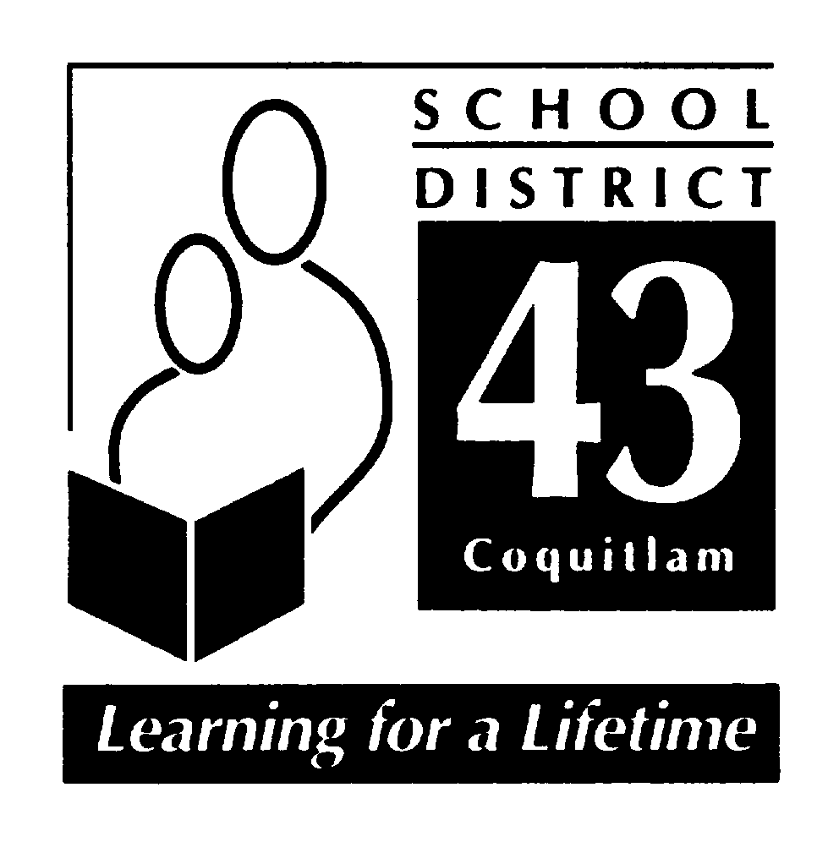

École Glenayre Elementary School

School Mission: Our Mission is to create an environment that celebrates every child’s unique strengths and supports different learning styles and rates of development. We encourage open communication between parents and school staff to help each child meet their individual potential.

- Introduction
This Code of Conduct has been developed in accordance with ministry requirements as outlined in the Safe, Caring and Orderly Schools’ document. Our school has developed this Code of Conduct with input from our school Parent Advisory Council, students, and teachers. Our Code of Conduct will be communicated to students, parents, staff, and community members. Each year our Code of Conduct is reviewed to ensure that it actively reflects our community needs, as well as aligning with current district and provincial school safety initiatives. Our Code of Conduct will be taught proactively, will be reinforced, and will be monitored.

- Code of Conduct Key Elements

- Process

Each June, the Parent Advisory Council (PAC) has an opportunity to review the school Code of Conduct. In May 2025, a formal review of the Code of Conduct involved members of our PAC and the Principal, Ms. Johnson. This code was reviewed to ensure that it continues to reflect our school community and its values.

- Communication

Our Code of Conduct is communicated to students, parents, staff, and community members. It is posted on our school website and in September, parents sign off on having read this important document. Our Code of Conduct is provided to all staff members who are assigned to our school during the school year.

- Implementation

Our Code of Conduct is taught proactively by teachers in the classroom environment and continues to be monitored for relevance to the emerging needs of our school community. Along with the Code of Conduct, positive social emotional skills are taught and recognized to students in class, assemblies, and school-wide events. The Code of Conduct is also modeled to students by staff and parents.

- Monitoring and Review

The Code of Conduct was last reviewed in May 2025. The review process included staff, students, and administration. It was then presented to our PAC at their June meeting.

- Alignment

The Code of Conduct was designed following dialogue with our family of schools. It follows the District and Provincial guidelines utilizing the template that was provided by our District.

- Standards

École Glenayre Elementary School subscribes to the values expressed in Section 8 of the BC Human Rights Code respecting the rights of all individuals in accordance with the law – prohibiting discrimination against a person or class of persons regarding any accommodation, service or facility customarily available to the public because of the indigenous identity, race, colour, ancestry, place of origin, religion, marital status, physical or mental disability, sex, or sexual orientation.

- Statement of Purpose

  - establish and maintain a safe, caring, and orderly environment for purposeful learning
  - to establish and maintain appropriate balances among individual and collective rights, freedoms, and responsibilities
  - to clarify and outline school expectations and acceptable student conduct both at school and when on school-approved functions (e.g., field trips).

- Conduct Expectations

These expectations apply to behavior at school, during school-organized or sponsored activities, and behavior beyond these times (including on-line behavior) that negatively impacts the safe, caring, or orderly environment of the school, and /or student learning.

Acceptable conduct is demonstrated by

- respecting oneself, others, and the school and community facilities
- informing a “tellable” adult, in a timely manner (in advance, if possible) of incidents of bullying, harassment or intimidation
- students not discriminating against others based on the race, colour, ancestry, place of origin, marital status, family status, age, religion, sex, or sexual orientation, or physical or mental disability, or for any other reason set out in the Human Rights Code of British Columbia (Section 7 and 8)
- students not publishing or displaying anything that would indicate an intention to discriminate against another, or expose them to contempt or ridicule, based on any such grounds
- engaging in responsible behavior in all learning and extra-curricular activities
- helping to ensure that the school environment is a safe, caring, and inclusive place for all to learn and play
- modeling respectful and responsible behavior at school, and in the community

Unacceptable conduct is demonstrated by

- Behaviour or communication that discriminates based on race, colour, ancestry, place of origin, religion, marital status, family status, physical or mental disability, sex, or sexual orientation (prohibited grounds set out in the BC Human Rights Code).

Unacceptable conduct is demonstrated by behaviors that

- Interfere with the learning and teaching environment of any school member
- Create an unsafe or dangerous learning environment
- Demonstrate a lack of caring for oneself, others, and the school community
- Display unkind acts or hurtful behaviors towards others (unkind/put down words, exclusion, physical violence, intimidation/bullying*)
- Using/naming a physical illness, disability, or condition to threaten, harass or intimidate others in the community is unacceptable.
- Involves the possession, use or distribution of illegal or restricted substances; possession or use of weapons; the theft of or damage to property.

*Bullying includes, but is not limited to, physical and verbal intimidation, verbal harassment, or cyber bullying, occurring both on and off school property. (Policy 17)
***Behaviors cited above are examples only and do not compromise an all-inclusive list. ***

Rising Expectations

As students in our school mature and progress from Kindergarten to Grade 5, there is a rising expectation of personal conduct and behavior. Social and emotional developmental milestones will be considered when working with students to develop positive behaviours or remediate unacceptable behaviours. Students are expected to

- Model positive behaviors for their peers and for younger students
- Support and reinforce appropriate behavior with all community members
- Demonstrate better self-regulation and implement conflict resolution skills with consistent reinforcement and practice throughout their years at our school

- Consequences

Our school will take all reasonable steps to prevent retaliation by any person against a student who has made a report of a breach of a code of conduct. Consequences will be applied to unacceptable student conduct, at an age- or developmentally appropriate level. Our guiding principle is that students can learn from their mistakes and the focus of our consequences should be restorative, rather than punitive, wherever possible and appropriate. Consequences will be implemented based on the severity and the frequency of the behaviors. Special considerations may apply to the imposition of consequences on a student with special needs if the student is unable to comply with this Code of Conduct, due to a disability of an intellectual, physical, sensory, emotional, or behavioural nature. Some of the possible consequences and remedies could include:
- Restitution
- Timeout
- Conflict resolution strategies
- Small group mediation
- School or community counseling
- Behavior support plans
- Informal suspension
- Formal suspension: District Code of Conduct: Suspension Process – Level I, II or III (for serious or dangerous behavior)
*** Special considerations may apply to the application of consequences on a student with special needs if the student is unable to comply with this Code of Conduct due to a disability of an intellectual, physical, sensory, emotional, or behavioural nature.

- Notification

When serious breeches of the code of conduct occur, school staff, based on their professional judgement and discretion, will contact the following when appropriate:
- parents of both students involved in an incident that contravenes acceptable behavior at school.
- SD43 School Board officials will be contacted as required by school district policy.
police and other agencies as required by law.
- school staff and as deemed appropriate by the school / district administration.
- all parents when deemed to be important to reassure members of the school community that school officials are aware of a serious situation and are takin appropriate action to address it.

1. District Code of Conduct – Policy 17

The Board believes it has a responsibility to establish expectations of students as part of its governance role for the District. The Board further believes that the responsibility for student discipline in school is shared among students, staff and parents. Students have a responsibility to respect the rights and dignity of others and to become actively and productively involved in their own academic learning and social growth. Educators are responsible for establishing a positive school climate in which structure, support and encouragement assist the students in developing a sense of self-discipline and responsibility. Parents are responsible for establishing a positive learning atmosphere in the home, knowing school policies and procedures, supporting the school in the enactment of these policies and procedures, and encouraging their children to understand and respect these policies and procedures. To support these aims, the Board has established a District Code of Conduct for Students, which shall be followed in all schools.

Specifically: The Board believes that appropriate student conduct, based on respect for oneself, respect for others, and respect for property is essential to the development of responsible citizens. To this end students are expected to:

• be aware of and obey all school rules
• attend classes punctually and regularly
• work cooperatively and diligently at their studies and with home assignments
• respect the rights of all persons within the school including peers, staff and parents
• respect the legitimate authority of the school staff
• respect the school’s physical school facilities
• respect the ethnic diversity of our school community
• behave in a safe and responsible manner at all times
• not threaten, harass, bully, intimidate or assault, in any way, any person within the school community
• not be in possession or under the influence of drugs and/or alcohol

2. Violence, Intimidation and Possession of Weapons - Policy 18

The Board believes that schools are purposeful places where students and staff must be able to work, learn and play without the threat of physical or psychological harm. Schools are characterized by sensitivity and respect for all individuals, an environment of non-violence, clear student behavioral expectations and disciplinary practices that are enforced consistently and fairly. The Board acknowledges its role in providing secure learning environments which are safe from threats, violence or intimidation.

Assessment of Risk to Others Protocol:

An assessment of Risk to Others will be initiated by the school’s multi-disciplinary team when behaviour includes, but is not limited to serious violence, or violence with intent to harm or kill, verbal/written threats to harm/kill others, internet/social media threats to harm/kill others, possession of weapons (including replicas), bomb threats and fire-setting.

3. Closure of Schools for Extreme Weather Conditions – AP 132

In the case of extreme weather conditions, the Superintendent or designate has authority, on behalf of the Board, to temporarily close a school.

Procedures: As a general expectation, parents are to be advised that schools are open. If parents believe the local conditions are unsafe, they may keep their child at home or arrange his/her early dismissal. If schools are to be closed before classes begin, an announcement will be made by 6:30 a.m. on the school district website and school websites. Announcements may also be made on School District 43 social media and local radio stations. For more information visit: www.sd43.bc.ca/NewsEvents/Pages/EmergencyInformation.aspx

4. Digital Responsibility for Students – AP 140-2

The District endorses the provision of district-wide network and Internet services to support student learning. While there are many benefits, there is also potential for misuse. Students are not permitted to create, distribute or access any material which is not suitable for classroom learning. When using technology, district electronic mail (email) services, social networking, collaboration, blogging, media sharing tools, in relation to their role, students and staff are expected to act as appropriate digital citizens as laid out in the procedures.

Specific to personal digital devices, all cellular phones or similar personal communication devices are to be appropriately stored during the school day. Digital devices of any kind are only to be used at the discretion of your teacher when identified as appropriate for your learning environment or because of unique circumstances.

Any use of personal digital devices at school is subject to all other expectations for conduct and use of technology, including AP 140.2 – Digital Responsibility for Students.

5. Tobacco and Vapour Products Free Environment – AP 171

All school property is designated “tobacco and vapour product free”. Therefore, every person, including a student, employee or visitor, is prohibited from smoking, using tobacco or vapour products of any kind, or holding lighted tobacco on school property at any time, including non-school hours.

6. Anti-Racism – AP 205
The District acknowledges the necessity of becoming responsive in a pluralistic society and affirms that the racial, ethno-cultural, linguistic and religious diversity of its students, staff, and community is a source of enrichment and strength for Canada. As an educational institution, the District has a special responsibility to develop positive values, attitudes, knowledge and practices by developing a framework to promote and support equity, justice and access to all.

7. Formal Intervention and Suspension of Students – AP 355
The effective management of student discipline is a necessity in establishing safe, caring and orderly school environments that foster student learning needs. When student misconduct occurs, the school and district must respond fairly, quickly, and effectively, imposing a disciplinary consequence that is appropriate to the circumstances and that reinforces for the student involved and students generally, appropriate standards of student behavior. The Principal has overall responsibility for the maintenance of student discipline and school rules. Under the general supervision of the Superintendent and subject to administrative procedures, a Principal and/or Vice Principal has the authority to suspend or remove a suspension imposed on a student.

8. Personal, Discriminatory, and Sexual Harassment – AP 356
The District recognizes the right of all students and staff members to learn and work in an environment free from personal, discriminatory or sexual harassment. The District, all staff members, students and people within school communities shall have a responsibility to promote, monitor and maintain learning environments and workplaces that are free from harassment, fear and discrimination.

9. Resolution of Student or Parent School Concerns – AP 380
The District encourages students and/or parents to discuss their questions or concerns regarding the education of their children with school personnel as early and as directly as possible.

Procedures: Students or parents who disagree with or wish to question decisions or actions that are taken by teachers and/or administrators are expected to seek a resolution by pursuing the following steps:

A. Teacher or Classroom Level Problem
1. Discuss the matter directly with the teacher whose judgement or decision is being questioned.
2. If not resolved, discuss your concern with the Principal.
3. If still unsatisfied with the outcome, discuss your concern with the Assistant Superintendent (contact the board office at 604-939-9201).
4. Unresolved matters may be referred to the Board as per Board Policy 13.

B. Principal or School Level Problem
1. Discuss directly with the Principal the action, policy, procedure or practice being questioned.
2. If not resolved, refer to the Assistant Superintendent (see contact information above).
3. If not resolved, refer to the Board as per Board Policy 13.
It is expected that SD43 personnel will seek a resolution to the problem as quickly as possible

