How to Make Course Selections on MyEd (Grades 10-12)
Step 1: Log in to MyEd
- When you are at the main menu, you will select the “My Info” button from the top menu options
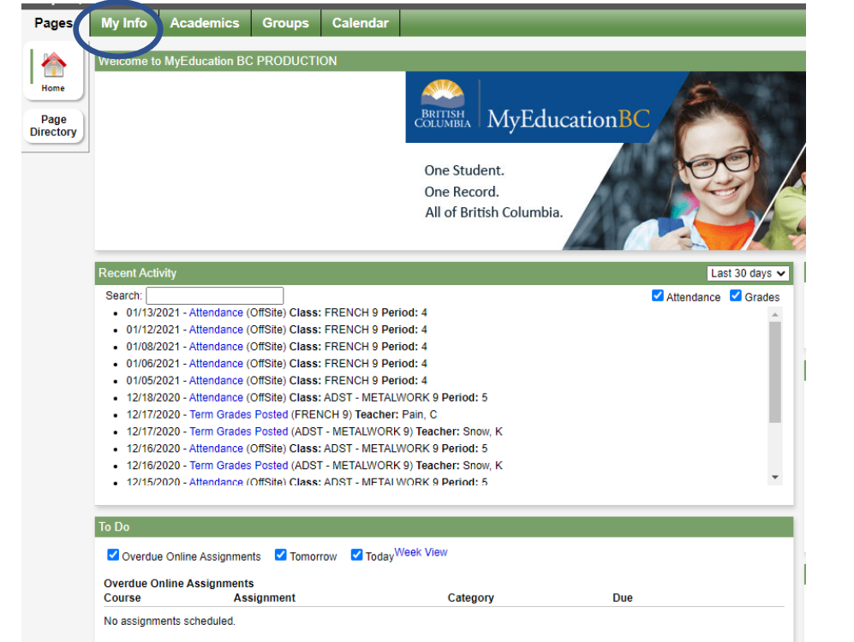
Step 2: Select Requests from the “My Info” screen options on the side menu.

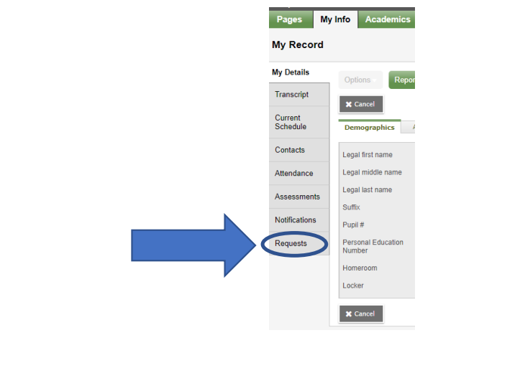
Step 3: Read the instructions, and CHOOSE your class options, electives, optional electives, and alternates. Select the REQUEST button for the options to choose from. This will be different at each grade level.
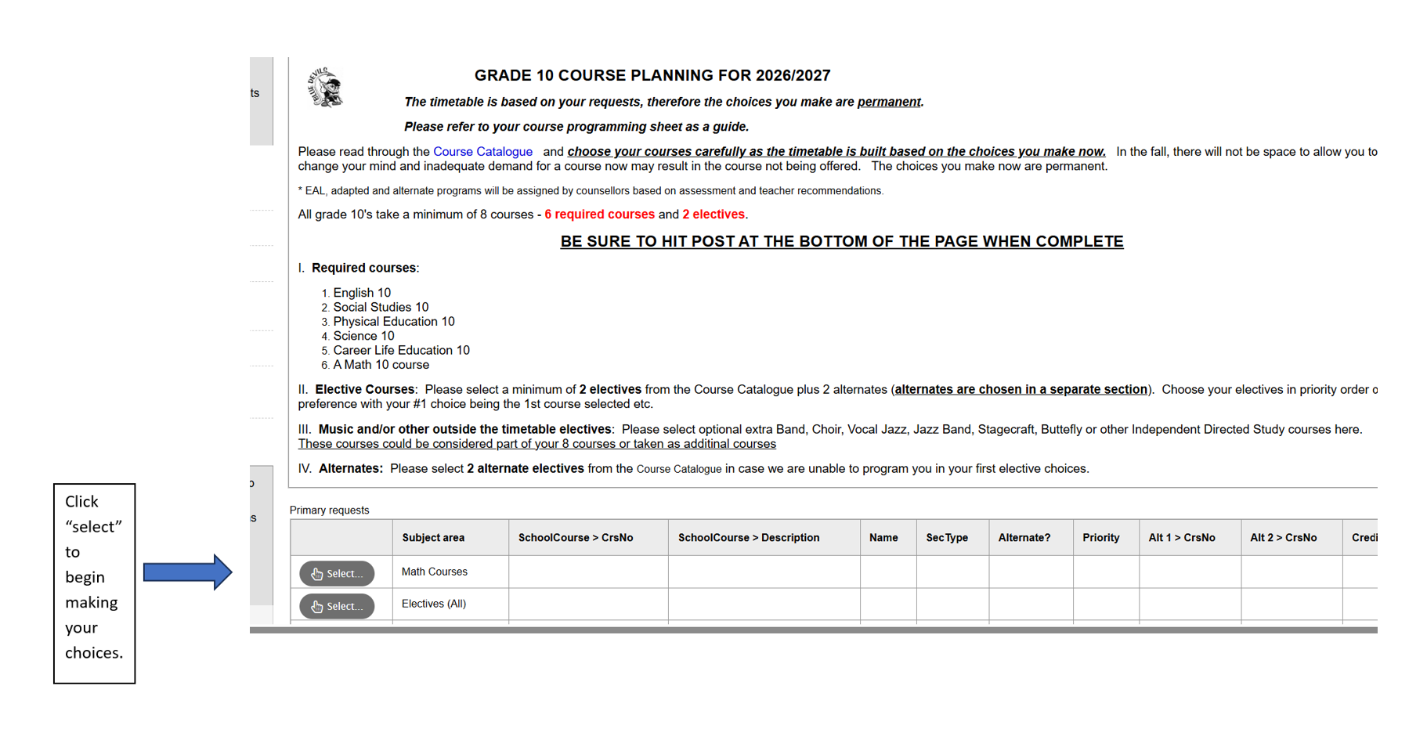Once you have selected the option, a new window will open for you to look at the choices and select what you want to take.
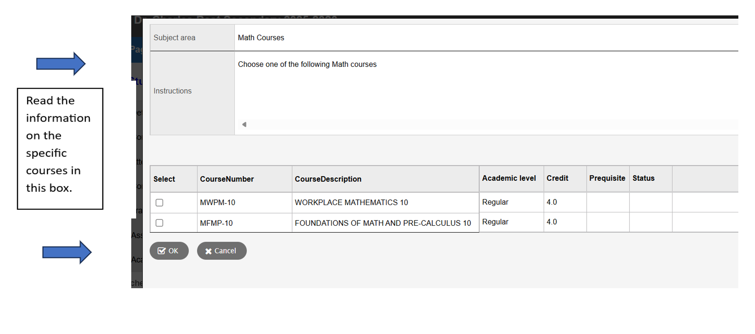

Click “OK” once you have made your selection
Electives
Sometimes there are multiple screens of options. Use the arrow to see the next screen for more choices to select from. Follow the instructions in the menu bar. 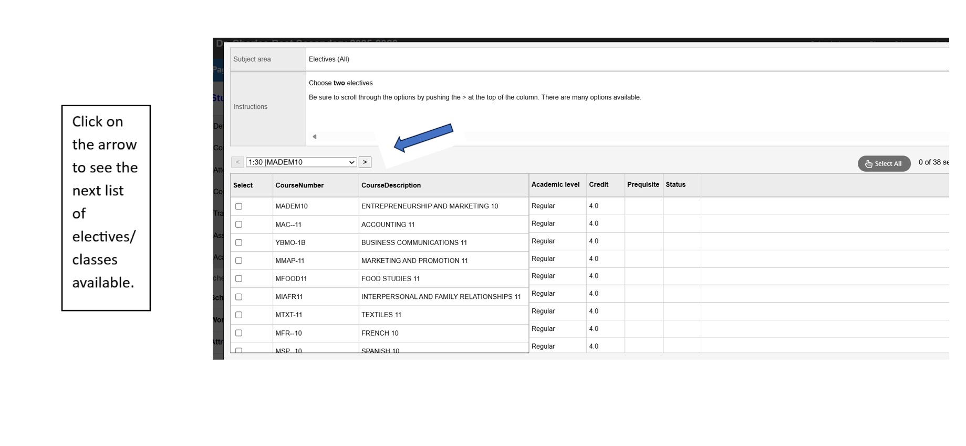
If you make a mistake, the system will tell you what it is. You will need to fix it before the system will let you move on.
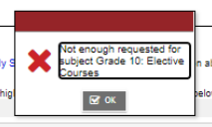

Optional Electives are music and other classes offered outside the regular schedule.
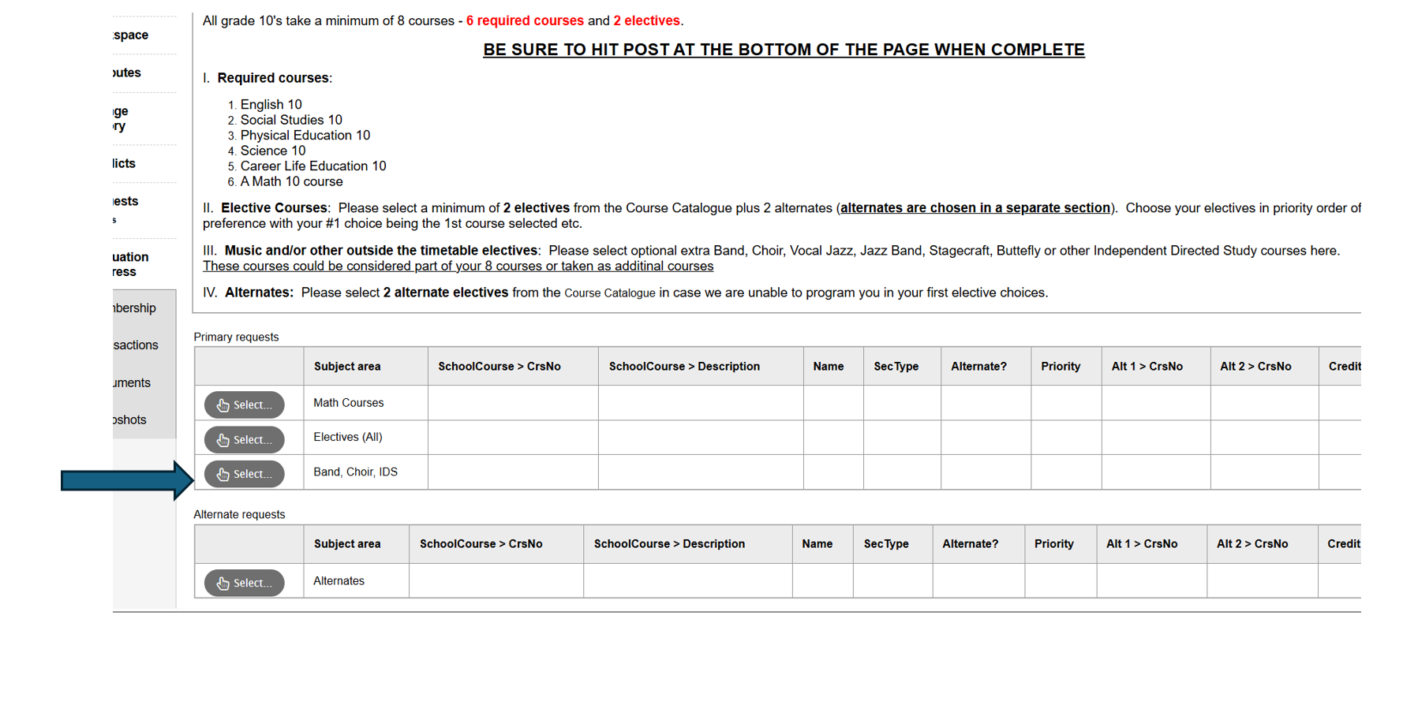
Please also select at least two Alternate electives.
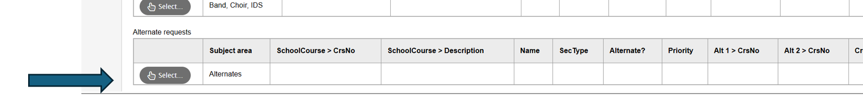
Step 4: Share notes with your counsellor
- If you have completed a grade 10/11/12 required class previously, and need to add an elective, leave a note for the counsellor, and they will take care of dropping the unneeded class. You can also let counsellors know of Summer School plans that you have. The counsellor will add one of your Alternate electives in place of the class you plan to complete at summer school.
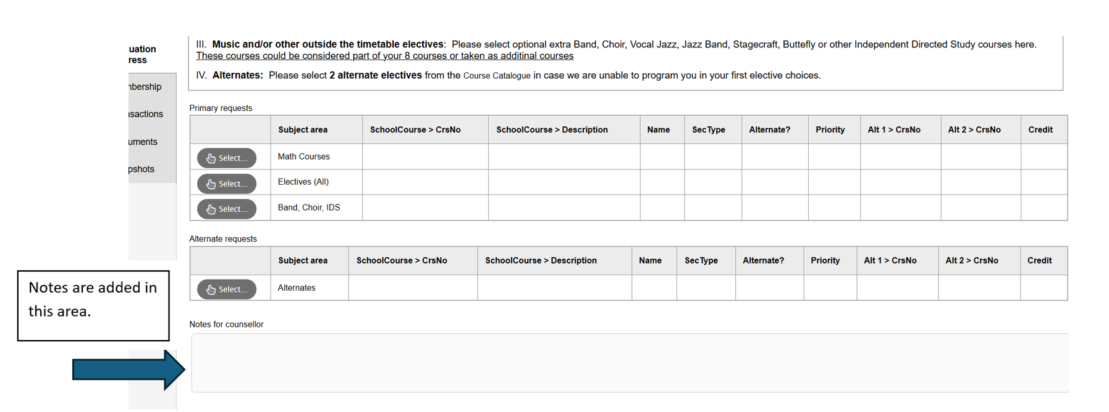

Step 5: POST!
- You can return as many times as you want to make changes up until the deadline, March 1st. Where necessary, counsellors may adjust your schedule for EAL/Learning Centre blocks, or to correct entries that were made without pre-requisite classes completed.
