Dr. Charles Best Secondary – Gr. 9 Course Selection (English)
A Quick Visual Guide
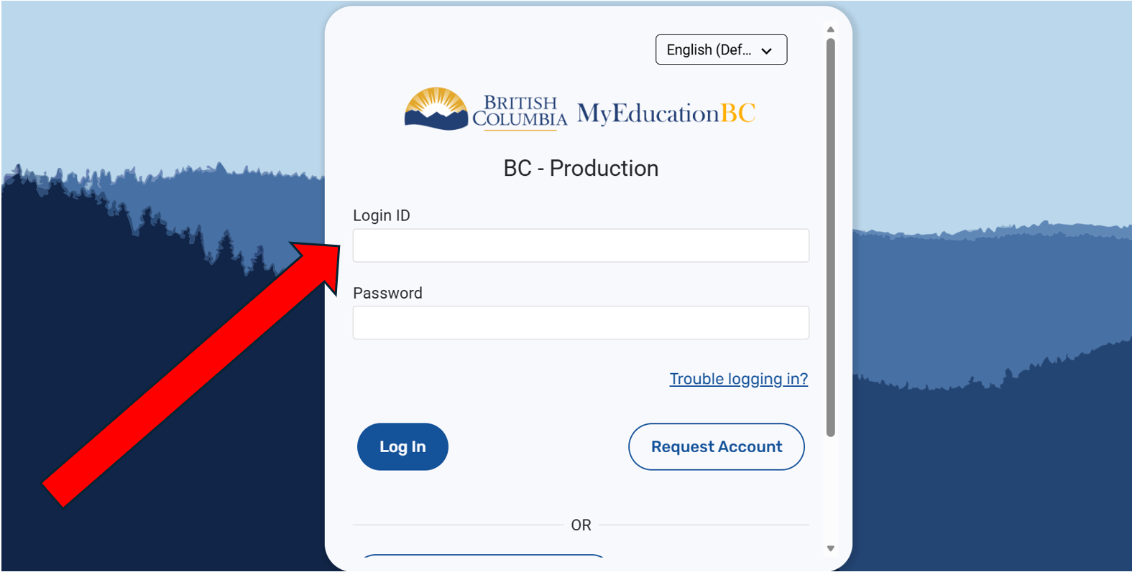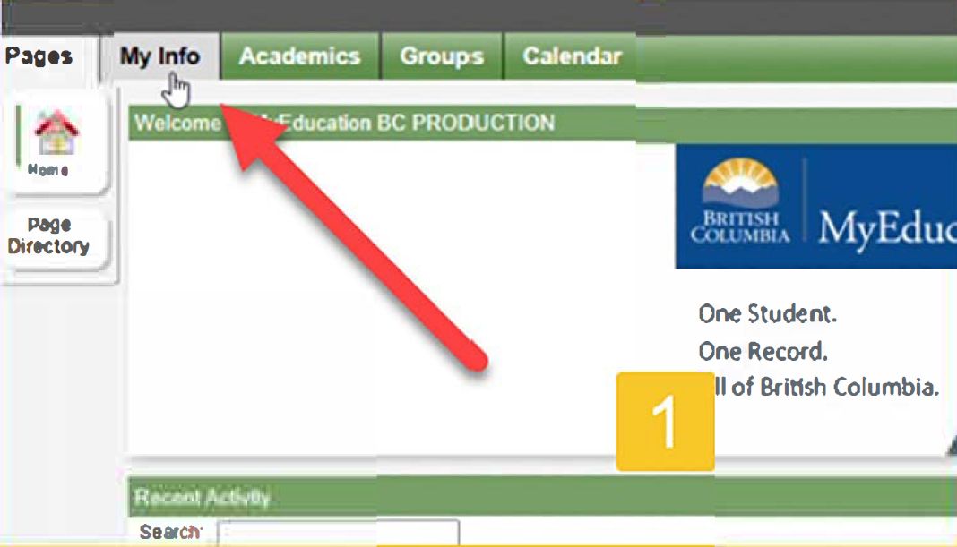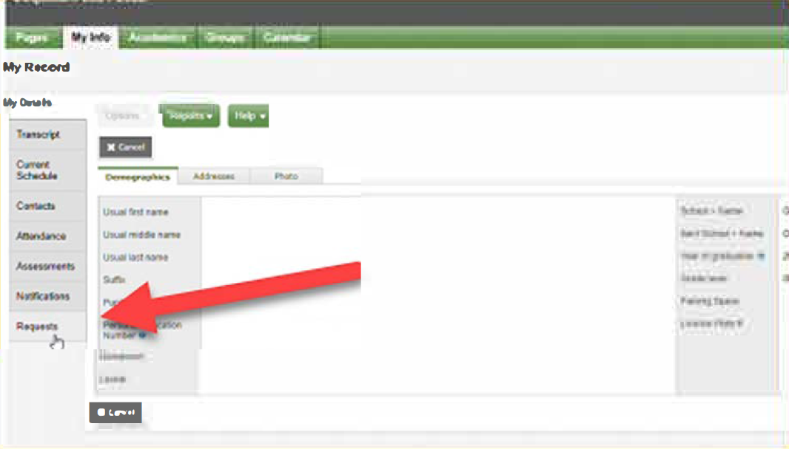
2. Click “My Info” in the top left corner.
3. Click “Requests” from the bottom of the sidebar.
1. Go to MyEd from Chrome, Firefox, or Edge on a PC (not phone) and login with your 7 digit pupil number (not e-mail address or PEN)

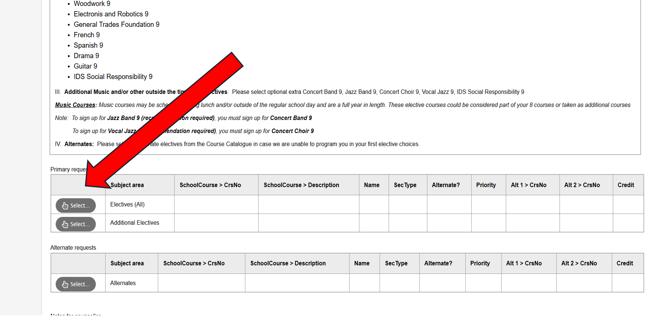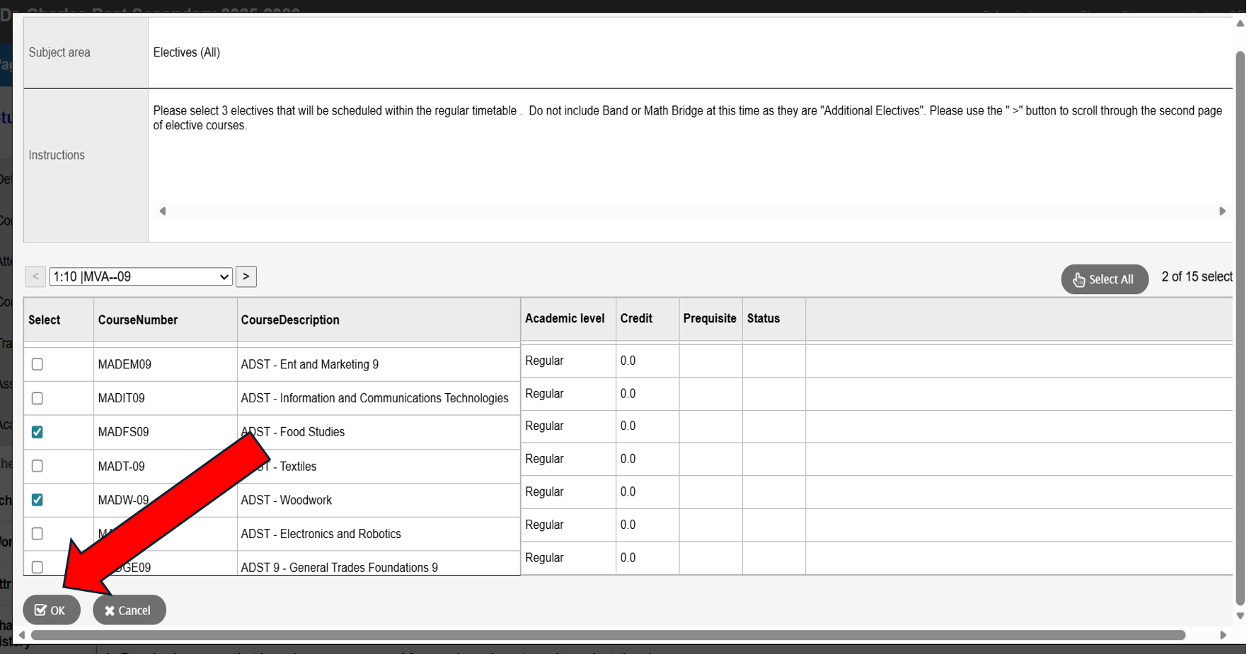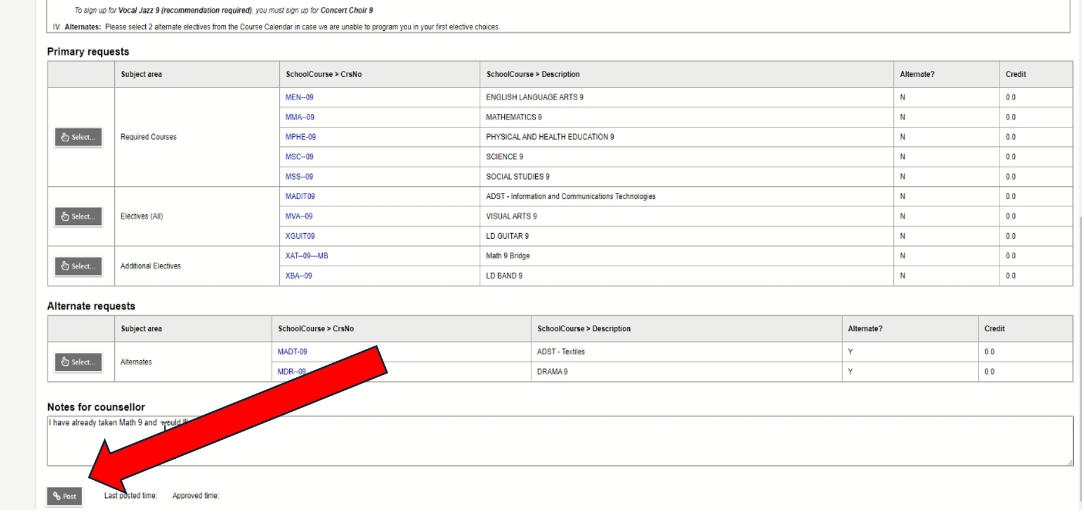
6. Repeat for Alternates section. Be sure to select and rank 2 alternate choices and click “OK”. IF applicable, repeat for Additional Electives. Then click “Post” button at the bottom left when you are all done.
4. READ ALL INSTRUCTIONS! When you are ready, press “Select” beside the Electives section.
5. Use the < > arrows to go to each page. Check the box next to the 3 electives you want. Once you have chosen your 3 electives, click “OK”.

