Grade 1 - School Supplies 2026 –2027
1 – HB2 Pencils (12 pack)
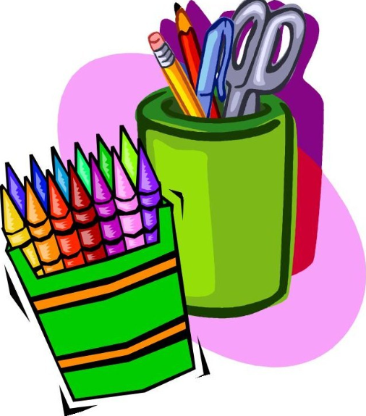
2 - White erasers
2 – Crayola wax crayons (16 colour pack)
1 – Crayola markers, fine tip (12 colour pack)
1 – Crayola Markers, broad tip (10 color pack)
1 – Crayola Watercolour Paint Set (24 colours)
1 – Scissors (7” sharp)
3 - Glue sticks (large)
2 – Sharpie Fine Point black (regular ones)
3 – Expo Dry Eraser Markers – small black
6 - Duo-Tangs – purple, dark blue, green, yellow, grey, light blue
2 - Hilroy Exercise Book, plain (72 pages)
3 – Hilroy Exercise books, ½ plain, ½ interlined
1 – Ucreate Watercolour Paper (12 sheet pack)
1 – Full Page dotted interlined
1 – Side opening Poly envelope w/Velcro closure (clear 8 ¾ x 11 ¾)
1 – Tissue box

